**SPATIOTEMPORAL DYNAMICS AND CLIMATIC DRIVERS OF EXTREME PRECIPITATION EVENTS IN GHANA: A SYNOPTIC AND ENSO INDICES ASSESSMENT**

# CHAPTER ONE: INTRODUCTION

## 1.0 BACKGROUND TO THE STUDY

In recent decades, the frequency and severity of extreme precipitation events have intensified globally, drawing attention to the complex interplay between climate variability and hydrometeorological hazards (De La Fuente et al., 2024). These events, characterized by unusually heavy or prolonged rainfall, pose significant risks to ecosystems, infrastructure, agriculture, and human livelihoods, particularly in regions with limited adaptive capacity. As the impacts of climate change become more pronounced, understanding the spatial and temporal dynamics of extreme rainfall has become a critical area of inquiry in climate science and disaster risk management (Chen et al., 2024).

West Africa, including Ghana, is especially vulnerable due to its reliance on rain-fed agriculture and its exposure to highly variable seasonal rainfall patterns influenced by both regional and global climatic systems (Kasei et al., 2019). While numerous studies have examined mean rainfall patterns in Ghana, comparatively less attention has been given to extreme precipitation events—their long-term trends, seasonality, and underlying drivers. This gap is particularly concerning given the increasing incidence of flash floods, crop failures, and infrastructure damage observed in various parts of the country.

Addressing this knowledge gap requires a comprehensive approach that integrates observational data from meteorological stations with high-resolution reanalysis datasets that capture atmospheric dynamics at multiple scales. Such integration allows for a deeper exploration of the synoptic and large-scale mechanisms that govern extreme precipitation, including influences from the West African Monsoon, El Niño-Southern Oscillation (ENSO), and shifts in the Inter-Tropical Convergence Zone (ITCZ) (Geen et al., 2020). Against this backdrop, this study aims to investigate the spatiotemporal behavior and climatic drivers of extreme precipitation events across Ghana, drawing on both station-based and gridded datasets to provide actionable insights for climate adaptation and risk reduction.

### 1.1.1 Global Context of Extreme Precipitation in a Changing Climate

Extreme precipitation events—defined as periods of unusually intense rainfall over short durations—have emerged as a critical focus of global climate research due to their rising frequency, intensity, and associated socio-economic consequences (Zittis et al., 2022). Scientific consensus from the Intergovernmental Panel on Climate Change (IPCC) confirms that the intensification of the global water cycle is one of the most robust signals of anthropogenic climate change. According to Jones et al. (2024) warmer global temperatures increase atmospheric moisture-holding capacity, in accordance with the Clausius-Clapeyron relation, which states that the water-holding capacity of the atmosphere increases by approximately 7% per degree Celsius of warming. This enhanced moisture availability often translates into more intense rainfall episodes, even in regions where total annual precipitation remains constant or decreases.

Global observational records over the past several decades show a discernible increase in heavy precipitation events, particularly in tropical and mid-latitude regions. Events that used to occur once in a decade are now recurring more frequently and with higher intensity, overwhelming stormwater infrastructure and triggering flash floods, landslides, and riverine flooding. Countries in Asia, Europe, and North America have all reported unprecedented deluges attributed to climate-induced shifts in storm dynamics (Garreaud et al., 2017). These events not only cause direct physical damage but also disrupt food security, displace populations, and strain emergency management systems.

Moreover, extreme rainfall is increasingly being linked to the alteration of large-scale atmospheric circulation patterns such as the jet stream, monsoon systems, and tropical cyclones. In this context, understanding the synoptic and thermodynamic factors underlying extreme precipitation events is vital for effective risk mitigation.

Despite these advances, knowledge of extreme rainfall dynamics remains regionally skewed, with limited attention to African contexts where observational networks are sparse and climate vulnerability is high. As developing countries, especially in tropical regions like West Africa, contend with the combined pressures of climate change and development challenges, there is a pressing need for localized, data-driven studies to understand the character, drivers, and risks of extreme precipitation events (Barriopedro et al., 2024). Ghana, in particular, presents a case of both exposure and vulnerability, warranting deeper scientific inquiry.

### 1.1.2 Regional Climate Variability in West Africa and Its Relation to Extreme Rainfall Events

West Africa’s climate is characterized by pronounced spatial and temporal variability, largely driven by the interaction between atmospheric circulation systems, oceanic conditions, and topographical features (Froude & Petley, 2018). One of the most influential systems affecting the region’s hydroclimate is the West African Monsoon (WAM), a seasonal wind reversal that brings moist southwesterly air masses from the Gulf of Guinea inland during the boreal summer months. The intensity, onset, and retreat of the WAM significantly determine the amount and distribution of rainfall across the region.

West Africa’s rainfall climatology is also modulated by other large-scale phenomena such as the Inter-Tropical Convergence Zone (ITCZ), the African Easterly Jet (AEJ), and the Tropical Easterly Jet (TEJ) (Rowell & Berthou, 2022). These systems govern the vertical motion and moisture convergence required for rainfall generation. Interannual climate variability, particularly driven by ocean-atmosphere interactions like the El Niño–Southern Oscillation (ENSO), further complicates the rainfall regime. ENSO phases have been shown to affect the timing and intensity of the monsoon, leading to shifts in the frequency of both droughts and heavy rainfall events across various sub-regions (H. Chen & Jin, 2019).

Extreme rainfall events in West Africa are often abrupt, highly localized, and intense, posing major forecasting challenges. These events may be associated with convective systems such as Mesoscale Convective Complexes (MCCs), which are common in the Sahel and Guinea Coast zones. With climate change, there is growing concern over the increasing occurrence of such high-impact rainfall events, despite long-standing regional issues with observational coverage and data reliability (Sankaran, 2019).

In recent years, research has shown that while total annual rainfall may remain constant or decline in some areas, the frequency and intensity of extreme rainfall events are on the rise. This paradox reflects the broader trend of rainfall becoming more erratic and concentrated within shorter periods—making it imperative to understand the regional drivers of extremes and their evolving patterns under a changing climate system.

### 1.1.3 Significance of Precipitation Extremes in the Ghanaian Context: Impacts on Agriculture, Infrastructure, Flood Risk, and Livelihoods

In Ghana, extreme precipitation events have become increasingly significant due to their wide-ranging impacts on key sectors such as agriculture, infrastructure, public health, and livelihoods (Dapilah et al., 2019). The country’s dependence on rain-fed agriculture means that any deviation from normal rainfall patterns—particularly in the form of intense and erratic downpours—poses a serious threat to food security and rural livelihoods (Azumah et al., 2016). Crops such as maize, cassava, and yam are highly sensitive to waterlogging, while prolonged wet conditions can delay planting, disrupt crop calendars, and reduce yields. Livestock production is also affected through waterborne diseases and damaged pasturelands.

Beyond agriculture, urban centers in Ghana—especially Accra, Kumasi, and Tamale—have become increasingly vulnerable to flooding due to poor drainage systems, unplanned settlements, and expanding impervious surfaces. Episodes of extreme rainfall often exceed the design capacity of existing drainage infrastructure, leading to flash floods that damage homes, displace residents, and disrupt economic activities (Angelakis et al., 2024). Notable flood events such as those in June 2010, October 2011, and June 2015 resulted in significant loss of life, destruction of property, and long-term socioeconomic setbacks.

Public health systems also experience heightened pressure during extreme precipitation events. Stagnant floodwaters create breeding grounds for mosquitoes and increase the risk of waterborne diseases such as cholera, typhoid, and hepatitis A. Schools, markets, and transport systems are routinely affected, especially in low-lying and informal settlements where resilience to climatic shocks is minimal.

In rural areas, floods caused by intense rainfall often damage feeder roads and bridges, cutting off access to healthcare, education, and markets. The poorest households—already facing structural vulnerabilities—tend to suffer the most from such events, reinforcing existing cycles of poverty and marginalization.

Given Ghana’s increasing exposure to climate extremes and the compounding risks associated with rapid urbanization and environmental degradation, it is crucial to analyze and understand the dynamics of extreme precipitation events to inform adaptation planning and disaster risk reduction strategies.

### 1.1.4 Spatial Heterogeneity of Rainfall in Ghana and the Role of Climatic Systems such as the West African Monsoon (WAM), ENSO, and ITCZ

Rainfall in Ghana exhibits significant spatial heterogeneity, reflecting the influence of latitudinal position, topography, proximity to the ocean, and the interplay of regional and global atmospheric systems. The country can be broadly divided into three agro-climatic zones: the southern forest zone, the transitional middle belt, and the northern savannah. Each of these zones experiences distinct rainfall regimes, ranging from bimodal patterns in the south to unimodal patterns in the north.

The West African Monsoon (WAM) plays a dominant role in shaping the rainfall climatology across Ghana. During the monsoon season, moist southwesterly winds from the Atlantic Ocean transport moisture inland, interacting with the local terrain and thermal gradients to trigger precipitation (Dieng et al., 2016). In the southern regions, this results in two distinct rainy seasons (April–June and September–November), while the northern sector typically experiences a single peak during June to September. The northward and southward migration of the Inter-Tropical Convergence Zone (ITCZ), a zone of maximum convection formed by the convergence of trade winds, further governs the seasonal progression and termination of rainfall, especially in the transitional and northern belts (Lashkari et al., 2017).

In addition to regional systems, Ghana’s rainfall variability is modulated by large-scale climate phenomena such as the El Niño–Southern Oscillation (ENSO). El Niño events are often associated with delayed monsoon onset and suppressed rainfall, particularly in the northern parts of the country, while La Niña episodes may enhance rainfall intensities and increase the likelihood of extreme events (McGregor & Ebi, 2018). These teleconnections exert their influence through modifications in the upper-level wind patterns, atmospheric pressure fields, and sea surface temperatures, which affect convection and moisture transport.

The spatial inconsistency in rainfall response across different parts of Ghana underscores the need for localized assessments. A uniform policy approach may not suffice, as each zone faces distinct exposure and vulnerability to precipitation extremes, necessitating region-specific monitoring, forecasting, and mitigation strategies.

## 1.2 PROBLEM STATEMENT

Over the past few decades, Ghana has experienced a noticeable increase in the frequency and intensity of extreme rainfall events (Kasei et al., 2019b). These high-impact occurrences have led to recurrent flash floods, significant infrastructural damage, and tragic losses of life, particularly in urban areas such as Accra, Kumasi, and Tamale. The June 3rd, 2015 flood and fire disaster in Accra, which claimed over 150 lives, stands as one of the most devastating examples of the consequences of unchecked extreme precipitation combined with inadequate drainage systems and unplanned urban expansion. These events are no longer isolated; they are becoming more frequent and widespread, affecting both rural and urban communities across the country. As climate change intensifies, the probability of such high-impact weather phenomena is projected to increase, further heightening the vulnerability of Ghana’s population and infrastructure (Calvin et al., 2024).

Despite the visible impacts, there is a marked gap in the understanding of the long-term behavior and underlying causes of extreme precipitation events in Ghana (Döring, 2019). Most existing studies have focused on general rainfall trends or seasonal droughts, often overlooking the distinct characteristics of short-duration, high-intensity rainfall events. This has resulted in a lack of clarity on the seasonality, recurrence, and spatial distribution of extreme rainfall across different agroecological zones in the country. As such, national and local planners lack sufficient data to anticipate when and where extreme precipitation is likely to occur, which is a critical barrier to effective disaster preparedness and climate risk management.

Additionally, the absence of integrated scientific frameworks that combine station-based observations with Enso indices limits the capacity to analyze the broader atmospheric mechanisms behind these events. The Ghana Meteorological Agency (GMET) provides vital daily precipitation data from synoptic stations; however, these data are limited in spatial coverage and do not provide insight into mid- to upper-level atmospheric dynamics.

Furthermore, there is a pressing need for synoptic-scale interpretation of extreme rainfall episodes to improve forecasting accuracy and inform adaptive planning. Understanding the synoptic precursors and large-scale drivers—such as the position of the Inter-Tropical Convergence Zone (ITCZ), the strength and behavior of the West African Monsoon (WAM), and the influence of the El Niño–Southern Oscillation (ENSO)—is crucial for anticipating extreme precipitation events (H. Chen et al., 2019). Without such knowledge, national meteorological and disaster management agencies remain reactive rather than proactive, often issuing warnings after the onset of rainfall rather than in advance.

Therefore, this study addresses an urgent scientific and policy-relevant problem: the lack of a comprehensive, integrated assessment of the trends, seasonality, and meteorological drivers of extreme precipitation events in Ghana. By combining GMET station data with composite analysis techniques, the study aims to fill a critical gap in the understanding of Ghana’s evolving precipitation extremes and provide a foundation for more targeted and timely climate adaptation strategies.

## 1.3 RESEARCH OBJECTIVES

1. To investigate the long-term trends, occurrence patterns, and magnitude of extreme precipitation events in the 22 synoptic stations in Ghana
2. To analyze the seasonality of extreme precipitation events in Ghana to identify peak months or seasons of occurrence within the study period.
3. To assess the influence of large-scale climate drivers such as the ENSO position on the occurrence of extreme precipitation events in Ghana

## 1.4 RESEARCH QUESTIONS

1. What are the temporal trends in the frequency and intensity of extreme precipitation events across the 22 synoptic stations in Ghana?
2. Which months or seasons record the highest occurrence of extreme precipitation events?
3. How do large-scale climatic drivers such as ENSO influence the occurrence and distribution of extreme precipitation in Ghana?

## 1.5 SIGNIFICANCE OF THE STUDY

This study holds multifaceted significance, cutting across scientific inquiry, methodological advancement, policy formulation, and practical applications in climate adaptation and risk management. While numerous studies have examined general rainfall trends or seasonal droughts, few have investigated the nature, timing, and atmospheric drivers of short-duration, high-intensity rainfall using both ground observations and global datasets. By incorporating Enso data with long-term GMET station records, this study provides a more comprehensive and dynamic understanding of the spatiotemporal patterns and synoptic-scale mechanisms underpinning extreme rainfall across different climatic zones in Ghana.

In terms of policy relevance, the findings of this study offer actionable insights that can inform national and regional disaster preparedness strategies, climate-smart agricultural planning, and climate-resilient infrastructure development. Extreme rainfall events pose serious threats to food production, water management, transportation systems, and urban development in Ghana. The ability to identify regions most susceptible to intense precipitation and to understand when such events are likely to occur provides a scientific basis for risk-sensitive development planning (Grote et al., 2021). For instance, flood-prone areas can be prioritized for enhanced drainage investment or early warning systems based on climatological peaks identified through this study.

From a methodological perspective, this research advances the application of composite anomaly analysis and synoptic interpretation using Enso data in a West African context.

Practically, the study’s outcomes can support the development of more reliable early warning systems and long-term resilience strategies. By identifying the atmospheric configurations and climate drivers most commonly associated with extreme rainfall events—such as ENSO phases or shifts in the ITCZ—decision-makers and forecasters can improve seasonal predictions and develop anticipatory response mechanisms (Collins et al., 2022). This can enhance the preparedness of local governments, NGOs, farmers, and urban planners, ultimately reducing the adverse impacts of extreme precipitation on lives, livelihoods, and infrastructure.

## 1.6 SCOPE AND DELIMITATION

This study is designed to offer a comprehensive analysis of the spatiotemporal dynamics and climatic drivers of extreme precipitation events in Ghana. The scope of the research is defined along three key dimensions—temporal, spatial, and thematic—to ensure focus, depth, and contextual relevance, while acknowledging specific boundaries that shape the research outcomes.

Temporally, the study covers a 34-year period from 1990 to 2024. This timeframe was chosen to provide a sufficiently long historical baseline to observe trends, variability, and evolving patterns in extreme precipitation. It also aligns with the availability and reliability of digitized daily rainfall data from the Ghana Meteorological Agency (GMET) and the corresponding Enso data. The period encompasses years of notable El Niño and La Niña activity, monsoon anomalies, and key hydrological events in Ghana, making it ideal for climatological trend analysis and composite interpretation.

Spatially, the study focuses on 22 synoptic meteorological stations distributed across Ghana's ecological and climatic zones. These stations provide daily precipitation records that form the observational basis for analyzing local and regional variations in extreme rainfall occurrences. The spatial scope captures coastal, forest, transitional, and northern savannah belts, ensuring that the analysis reflects Ghana's full climatic diversity and highlights regional disparities in rainfall extremes.

Thematically, the research centers specifically on *extreme precipitation events*, as defined by high percentile thresholds (e.g., 90th or 95th percentiles) of daily rainfall values. Moderate or normal rainfall events are excluded from the scope, as the focus is on high-impact events with significant implications for flood risk, infrastructure, and livelihoods.

Delimitations of the study are acknowledged to clarify the boundaries of analysis. First, the study relies on secondary data from GMET and Enso data, rather than conducting field-based measurements or deploying instruments. This choice ensures consistency and wide coverage but limits the resolution of near-surface microclimatic effects. Second, the composite analysis of atmospheric anomalies focuses on major known climatic drivers such as the El Niño–Southern Oscillation. Lesser-known or less frequently occurring phenomena like the Madden-Julian Oscillation (MJO) or Saharan heat lows are not explicitly analyzed.

These defined boundaries ensure clarity of focus and analytical feasibility while maintaining the depth required for meaningful interpretation and application.

## 1.7 ORGANIZATION OF THE STUDY

This research is structured into five main chapters, each designed to build upon the previous to form a coherent and comprehensive analysis of extreme precipitation events in Ghana and their associated climatic drivers. The organization reflects the logical flow of a scientific inquiry—from establishing the problem context to interpreting results and deriving actionable insights.

Chapter One serves as the foundation of the study by introducing the research problem and placing it within both global and national contexts. It presents a detailed background on the increasing frequency and severity of extreme rainfall events globally and in Ghana, underscoring their implications for agriculture, infrastructure, and livelihoods. The chapter outlines the specific problem to be addressed, defines the research objectives and questions, and highlights the significance of the study from scientific, methodological, and policy perspectives. It also clarifies the scope and delimitations of the study and concludes with an outline of the structure of the entire research document.

Chapter Two is devoted to the review of relevant literature. It explores key theoretical concepts and frameworks related to extreme precipitation, including definitions, statistical thresholds, and synoptic meteorology. The chapter also reviews empirical studies on rainfall variability and extremes in Ghana, West Africa, and other tropical regions. Special attention is given to literature addressing the roles of large-scale climate drivers such as ENSO, the West African Monsoon, and the ITCZ. Gaps in the current body of knowledge are identified, particularly the lack of studies integrating station observations with reanalysis data to assess the drivers of extreme rainfall events in Ghana.

Chapter Three describes the methodology used in the study. It explains the quantitative research design and outlines the data sources, including GMET’s daily rainfall observations and Enso datasets. It details the data quality control procedures, trend and frequency analysis methods, and techniques for spatial mapping and synoptic composite analysis. The chapter also identifies the statistical and visualization tools employed—such as Python, R, and QGIS—and justifies the use of these methods for achieving the research objectives.

Chapter Four presents the results of the study. It includes trend analyses of extreme rainfall frequencies and intensities, seasonal distribution patterns, and spatial mapping across the 22 synoptic stations. The chapter also provides composite anomaly maps and synoptic interpretations derived from Enso data, highlighting the atmospheric configurations and climatic drivers associated with extreme precipitation episodes.

Chapter Five concludes the study with a detailed discussion of findings in relation to existing literature. It interprets the results, identifies consistencies and deviations from previous studies, and offers conclusions that respond directly to the research questions and objectives. The chapter further provides policy-relevant recommendations, suggests practical applications for early warning systems and disaster management, and outlines areas for future research.

# CHAPTER TWO: LITERATURE REVIEW

## 2.0 INTRODUCTION

Understanding the dynamics of extreme precipitation requires a solid foundation in both theoretical and empirical literature, particularly in the context of climate variability, atmospheric circulation, and regional hydroclimatic behavior (De Paiva et al., 2020). This chapter reviews key conceptual frameworks, scientific definitions, and analytical approaches that inform the study of extreme rainfall, with a specific focus on Ghana and the broader West African region.

The literature review begins by clarifying the core concepts and terminologies related to extreme precipitation. This includes percentile-based definitions, statistical thresholds, and metrics such as intensity, frequency, duration, and return periods. These metrics are essential for identifying and quantifying extremes in a consistent and comparable manner. In addition, standardized climate indices like R95p, RX1day, and SDII—commonly used in global and regional precipitation studies—are discussed to contextualize their relevance for detecting significant events.

Following the conceptual discussion, the chapter presents the theoretical framework underpinning the study. This includes perspectives from synoptic climatology, dynamical meteorology, and reanalysis climatology. Particular attention is paid to large-scale teleconnections—such as the El Niño–Southern Oscillation (ENSO), the Inter-Tropical Convergence Zone (ITCZ), and the West African Monsoon (WAM)—which are known to influence rainfall variability across West Africa.

The empirical section of the review synthesizes findings from global, regional, and Ghana-specific studies. It highlights past work on rainfall trends, seasonal patterns, and climate-driver relationships, while also identifying methodological advancements and limitations. The chapter concludes by outlining key knowledge gaps, particularly the underutilization of long-term homogenized datasets, the limited integration of Enso indices with station data, and the lack of composite and synoptic-scale approaches in Ghanaian climate research. These gaps form the basis for the analytical direction and justification of the present study.

## 2.1 CONCEPTS AND DEFINITIONS

### 2.1.1 Definition of Extreme Precipitation

According to the Climate Change 2014 - Synthesis Report, extreme precipitation refers to rainfall events that significantly exceed normal levels within a given time frame, causing disruptions to environmental and human systems. Conceptually, extreme precipitation differs from average or moderate rainfall not merely in volume, but in the rate of accumulation, intensity, and the short duration over which it occurs (Heckmann et al., 2018). While average precipitation patterns help in defining climatic norms, extreme events are anomalies that pose considerable risks due to their potential to induce floods, landslides, and infrastructure failure.

The characterization of what qualifies as “extreme” varies by context and application. In meteorology, extreme precipitation is typically defined using statistical threshold methods, which classify rainfall as extreme when it exceeds a certain percentile of the historical rainfall distribution. Common thresholds include the 90th, 95th, and 99th percentiles, computed from long-term daily precipitation records (Karki et al., 2017). For example, an event is considered extreme if its daily total exceeds the 95th percentile of all daily rainfall amounts recorded during a baseline period (e.g., 1991–2020). This method adjusts for local climatic conditions and enables a standardized identification of extremes across diverse regions.

In contrast to percentile-based definitions, some studies adopt event-based thresholds, particularly for operational or impact-oriented analyses. In Ghana, for instance, rainfall amounts equal to or exceeding 50 mm in a single day are often categorized as extreme due to their capacity to overwhelm urban drainage systems and saturate agricultural soils (Clavin et al., 2017). Such fixed thresholds are useful for decision-making but may not capture local variations in climate sensitivity, especially across different agroecological zones.

Moreover, a key distinction exists between meteorological and hydrological extremes. Meteorological extremes are defined solely by atmospheric conditions—such as intense rainfall within a 24-hour period—whereas hydrological extremes refer to the consequences of this precipitation on the hydrological system, such as river flooding, runoff, and groundwater recharge(Gidhagen et al., 2019). Not all meteorological extremes lead to hydrological disasters, as the outcome depends on antecedent soil moisture, topography, and land use. Nonetheless, in many tropical settings, intense rainfall is closely linked to hydrological hazards due to high runoff coefficients and limited infiltration capacity.

The World Meteorological Organization (WMO) and other international bodies increasingly recommend using a combination of statistical, event-based, and impact-based approaches to define extreme precipitation(Merz et al., 2020). These hybrid definitions help bridge the gap between scientific identification and real-world implications. For instance, the Expert Team on Climate Change Detection and Indices (ETCCDI) promotes percentile-based indices, while disaster management agencies may prioritize operational thresholds to trigger alerts and deploy emergency response systems (Kim et al., 2020).

Ultimately, the definition of extreme precipitation must be tailored to the purpose of the analysis—whether it is climatological trend detection, hydrological modeling, disaster preparedness, or agricultural planning(Hagenlocher et al., 2019). For this study, a percentile-based approach is adopted, using the 90th and 95th percentiles of daily precipitation to define extreme events across 22 synoptic stations in Ghana. This allows for spatial consistency and comparability across regions with different climatic regimes. Complementary event-based thresholds (e.g., ≥50 mm/day) may also be used to contextualize findings within local impact frameworks, especially in flood-prone urban areas like Accra and Kumasi.

### 2.1.2 Metrics for Analyzing Extremes

The assessment of extreme precipitation events requires a robust set of quantitative metrics that capture different dimensions of these phenomena, including how often they occur (frequency), how intense they are (intensity), and how long they last (duration). These metrics provide the foundation for climatological analyses, trend detection, risk assessment, and policy planning. In this study, the selection of metrics is aligned with international standards, particularly those developed by the World Meteorological Organization (WMO) and the Expert Team on Climate Change Detection and Indices (ETCCDI), ensuring comparability and scientific rigor (Calvin et al., 2024b).

#### 2.1.2.1 Frequency

Frequency refers to the number of times extreme precipitation events occur within a defined temporal interval, typically per year or per season. This metric is crucial in understanding whether extreme rainfall is becoming more common over time, a key indicator of changing climatic patterns (González et al., 2019). Frequency can be computed by counting the number of days in a year where rainfall exceeds a certain threshold, such as the 90th or 95th percentile of daily rainfall values derived from a baseline climatological period (e.g., 1990–2020).

For example, if a station records more than 10 days annually where daily rainfall exceeds its local 95th percentile, it may be experiencing a higher frequency of extremes. Trends in frequency help identify areas facing increasing hydrometeorological risks, particularly when analyzed alongside exposure and vulnerability data (Cradock-Henry, 2021). In Ghana, a rise in the frequency of extreme rainfall days in coastal or urban zones could imply greater flood risk, even if the overall annual rainfall remains stable or declines.

#### 2.1.2.3 Intensity

Intensity refers to the magnitude of rainfall received during an extreme event, typically measured in millimeters per event or per day. It is a critical metric because the destructive potential of rainfall is often more closely tied to intensity than to duration or frequency alone (Xin et al., 2022). High-intensity rainfall can cause flash flooding, trigger landslides, and damage crops within a short time span. In climatological analyses, intensity is often measured using indices like RX1day (maximum 1-day precipitation amount) and RX5day (maximum 5-day cumulative precipitation).

For percentile-based approaches, intensity can be assessed by calculating the mean precipitation amount on days exceeding a given percentile (e.g., R95pTOT for total rainfall from days above the 95th percentile). Comparing intensity values across years and locations helps identify whether rainfall events are becoming stronger, even if they are not more frequent. This is particularly relevant for Ghana, where isolated heavy storms can cause localized disasters without showing up as frequent events in broader datasets (Fan et al., 2019).

#### 2.1.2.4 Duration

Duration captures how long an extreme rainfall episode persists, typically in terms of the number of consecutive days with rainfall above a certain threshold. Long-duration rainfall events are particularly damaging because they can saturate soils, exceed reservoir capacities, and maintain elevated river levels, increasing the likelihood of both urban and riverine flooding (Zittis et al., 2022b). Duration is commonly measured using indices such as CDD (consecutive dry days) and CWD (consecutive wet days), which help distinguish between short, sharp storms and prolonged rainfall periods.

In this study, the duration metric focuses on the number of consecutive days exceeding the extreme threshold (e.g., 90th percentile), which provides insight into whether extreme events are clustering or remaining isolated. For instance, an event spanning three consecutive days with 60 mm/day rainfall will likely have more severe implications than a single 80 mm downpour. Analyzing such durations is important for infrastructure design, particularly in the construction of drainage systems and agricultural planning, where water saturation levels are crucial.

These three core metrics—frequency, intensity, and duration—offer a multidimensional understanding of extreme precipitation. Their combined analysis enables researchers to detect not only how often and how severe extreme events are but also how their temporal structure evolves over time. Importantly, they allow for spatial comparisons across agroecological zones in Ghana, where the nature of rainfall extremes may differ significantly between the southern forest belt and the northern savannah.

In this study, these metrics are calculated using daily precipitation data from 22 synoptic stations, with results used to assess long-term trends, seasonal distributions, and spatial patterns of extremes. Together, they provide the empirical basis for understanding Ghana’s exposure to climate-induced rainfall hazards and for developing targeted adaptation measures in vulnerable regions.

### 2.1.3 Return Periods and Recurrence Intervals

Understanding the likelihood of extreme precipitation events is essential for risk management, engineering design, and climate adaptation planning. This is where the concepts of return period and recurrence interval become particularly important (Ganguli & Coulibaly, 2017). These concepts provide a probabilistic estimate of how often a particular rainfall magnitude is expected to occur based on historical observations, and they form the cornerstone of hydrological design and disaster risk assessment frameworks.

#### 2.1.3.1 Concept of Return Periods in Hydrometeorology

A return period (also called recurrence interval) refers to the average time between events of a certain intensity or size. For example, if a rainfall event with a depth of 100 mm in 24 hours has a return period of 10 years, it means that, on average, such an event is expected to occur once every 10 years. However, it does not imply that the event will occur exactly every 10 years—it could happen twice in one decade or not at all. Rather, it indicates a probabilistic frequency, where the annual exceedance probability (AEP) of a 10-year event is 10% (i.e., 1/10) (Brantley et al., 2017).

Return periods are particularly useful in infrastructure design, such as sizing drainage systems, culverts, bridges, and stormwater facilities (Stoelzle et al., 2014). They help engineers assess the level of protection required for a specific infrastructure based on the anticipated severity and frequency of rainfall. In Ghana, where intense rainfall has caused repeated urban flooding and structural failures, incorporating updated return period estimates into design guidelines is becoming increasingly necessary.

#### 

#### 2.1.3.2 Applications in Infrastructure and Flood Risk Planning

Return period analysis is vital for designing climate-resilient infrastructure in both rural and urban settings. Engineering codes in many countries, including Ghana, rely on specific return periods (e.g., 10-year for minor roads, 25- or 50-year for major urban drainage systems) to determine structural specifications (Watts et al., 2018). However, with increasing climate variability and rapid urbanization, return period estimates based on outdated or short-term records may no longer reflect the true risk. Updating return levels using recent data helps ensure that critical facilities are not under designed.

In the context of disaster risk reduction, return period estimates help in zoning flood-prone areas, issuing rainfall warnings, and formulating contingency plans. For instance, emergency agencies can prioritize evacuation protocols or deploy resources more effectively if a forecasted rainfall event is associated with a historically rare return period (e.g., 1-in-100-year storm).

In summary, return periods and recurrence intervals offer a probabilistic lens through which extreme rainfall risk can be quantified and communicated. By applying robust statistical methods like the Gumbel or GEV distributions to Ghana’s synoptic station data, this study enhances the predictive understanding of high-magnitude rainfall events and their implications for planning, design, and preparedness.

### 2.1.4 Climate Indices Relevant to Extremes

Climate indices are standardized metrics developed to quantify specific aspects of weather and climate extremes, especially temperature and precipitation anomalies. These indices are vital tools for understanding patterns, trends, and changes in extreme events over time. In the context of extreme precipitation, several indices have been developed under the World Meteorological Organization’s Expert Team on Climate Change Detection and Indices (ETCCDI) (Dunn et al., 2024). These indices facilitate comparative studies across regions and timeframes and provide insight into both the intensity and frequency of precipitation extremes.

**2.1.4.1 RX1day and RX5day (Maximum One-Day and Five-Day Precipitation)**

We understand from Zhou et al. (2018), that the RX1day index refers to the highest single-day rainfall within a year, while RX5day captures the highest cumulative rainfall over five consecutive days. These indices are widely used to assess the potential for extreme flooding, especially in urban environments where drainage systems can be overwhelmed by intense short-term downpours.

In Ghana, RX1day and RX5day are particularly important in the design of infrastructure and early warning systems. A consistent upward trend in RX1day, for instance, would indicate an increased risk of flash flooding. RX5day is crucial for identifying prolonged rainfall events that may lead to riverine flooding and soil saturation, affecting both urban settlements and agricultural fields.

#### 2.1.4.2 Relevance in Global and Regional Studies

These ETCCDI indices are internationally recognized and have been widely used in IPCC reports, regional climate assessments, and peer-reviewed studies. Their standardization allows researchers to compare trends across countries and ecosystems and to detect global-scale shifts in precipitation behavior. In Africa, these indices have been applied to assess rainfall extremes in the Sahel, Guinea Coast, and East Africa, providing insights into climate-induced vulnerabilities and adaptation priorities (Kostopoulou & Giannakopoulos, 2024).

In Ghana, however, there is limited research that applies the full suite of ETCCDI precipitation indices. Most existing studies focus on annual totals or use fixed thresholds without fully leveraging the diagnostic capabilities of percentile-based indices (Cheng & Zhang, 2022). By incorporating indices such as R95p, RX1day, and SDII into the analysis, this study fills a methodological gap and aligns with global best practices in climate research.

## 2.2 THEORETICAL FRAMEWORK

### 2.2.1 Synoptic Climatology and Dynamical Meteorology Foundations

Synoptic climatology and dynamical meteorology provide a vital theoretical foundation for understanding the atmospheric conditions that give rise to extreme precipitation events. Synoptic climatology, in particular, focuses on the identification and classification of large-scale atmospheric patterns that influence weather phenomena across spatial and temporal scales. It emphasizes the role of pressure systems, frontal boundaries, jet streams, and other organized features of the atmosphere in driving weather events, including high-impact rainfall episodes (Jones et al., 2022).

#### 2.2.1.1 Principles of Synoptic-Scale Meteorological Systems

Synoptic-scale systems typically refer to atmospheric phenomena that span hundreds to thousands of kilometers and persist for several days. These include surface and upper-level pressure systems, cyclones and anticyclones, troughs and ridges, and monsoonal circulations (De Vries, 2021). In the context of precipitation extremes, synoptic systems are of interest because they serve as the large-scale environment in which mesoscale or convective-scale weather systems develop and organize.

In West Africa, and particularly Ghana, synoptic features such as the African Easterly Jet (AEJ), Tropical Easterly Jet (TEJ), and the Inter-Tropical Convergence Zone (ITCZ) interact with localized convection and surface heating to influence rainfall distribution and intensity. Synoptic climatology allows researchers to associate observed precipitation extremes with specific atmospheric configurations—such as a deep trough aloft, strong low-level moisture convergence, or enhanced divergence at upper levels.

#### 2.2.1.2 Atmospheric Circulation Patterns Associated with Rainfall

Several atmospheric circulation patterns are frequently associated with extreme rainfall in tropical regions according to Ngarukiyimana et al. (2017):

* Troughs are elongated zones of low pressure, typically found in the mid- to upper troposphere. In Ghana, troughs can enhance vertical motion and instability, leading to convective development, especially when aligned with moist inflows from the Atlantic.
* Convergence zones, including the ITCZ and mesoscale convergence lines, are critical for rainfall development. These zones are characterized by the meeting of opposing air masses, which forces upward motion and condensation. The ITCZ migrates seasonally and is closely tied to the monsoon onset and retreat.
* Monsoon surges refer to bursts or intensifications of moist southwesterly winds during the monsoon season. These surges are often linked with low-pressure systems over the Sahara or the Gulf of Guinea and can trigger widespread rainfall in Ghana.

Other mechanisms include tropical waves and cyclonic vorticity advection, which contribute to the organization of rainfall systems on synoptic scales.

#### 2.2.1.3 Role of Vertical Motion, Convection, and Moisture Flux

The initiation and sustenance of extreme precipitation require a combination of atmospheric instability, sufficient moisture, and strong vertical motion. These elements are often captured in dynamical meteorology through variables such as geopotential height fields, omega (vertical velocity), precipitable water, and convective available potential energy (CAPE) as indicated by (Wolding et al., 2016);

* Vertical motion is essential in lifting moist air to levels where condensation occurs, releasing latent heat and further enhancing upward motion. Areas of large-scale ascent, indicated by negative omega values at mid-levels (e.g., 500 hPa), are often precursors to extreme rainfall.
* Convection—especially deep convection—is the main process through which rainfall is produced in the tropics. Convection is triggered by surface heating, orographic lifting, or convergence and is maintained by favorable thermodynamic conditions in the atmosphere.
* Moisture flux and its convergence are crucial in supplying the water vapor needed for rainfall generation. In Ghana, moisture is primarily transported by southwesterly winds from the Atlantic Ocean. Analysis of low-level wind vectors (e.g., at 850 hPa) and moisture convergence fields helps in diagnosing the conditions leading to intense precipitation.

By combining synoptic-scale pattern recognition with dynamical meteorological variables, researchers can develop a holistic understanding of the drivers of extreme rainfall. This framework supports diagnostic efforts using reanalysis datasets, satellite observations, and station data to pinpoint the atmospheric precursors to high-impact weather events.

In this study, the synoptic and dynamical frameworks serve as the basis for interpreting ERA5-derived composites of wind, pressure, and vertical motion fields during extreme rainfall episodes. This theoretical lens is essential for linking large-scale circulation patterns with localized impacts, thereby enhancing both scientific understanding and the predictive capability of Ghana’s meteorological system.

#### 2.2.3.1 El Niño–Southern Oscillation (ENSO): Influence on West African Rainfall

ENSO is a coupled ocean-atmosphere phenomenon centered in the equatorial Pacific Ocean. It has two primary phases: El Niño, characterized by warmer-than-average SSTs in the central and eastern Pacific, and La Niña, marked by cooler-than-average SSTs (Ropelewski & Halpert, 1986). These phases disrupt global atmospheric circulation and influence rainfall patterns far beyond the Pacific.

In West Africa, ENSO influences the strength and onset of the West African Monsoon (WAM) and alters the position of the ITCZ. El Niño events are generally associated with suppressed rainfall in the Sahel and northern Ghana during the core monsoon season (June–September). This suppression is due to weakened moisture advection from the Gulf of Guinea and a delayed northward migration of the ITCZ. Conversely, La Niña events tend to enhance monsoon circulation, promoting wetter conditions and, in some cases, increasing the frequency of extreme rainfall events (Geen et al., 2020b).

Several studies have documented that El Niño years (e.g., 1982–83, 1997–98, 2015–16) in Ghana are often accompanied by reduced rainfall and shorter growing seasons in the northern savannah regions. In contrast, La Niña years can lead to more intense rainfall, occasionally resulting in flash floods and riverine inundation, especially in the transitional and northern zones. ENSO’s influence is often strongest during boreal summer, aligning with Ghana’s main rainy season, making it a key teleconnection for seasonal forecasting and early warning systems.

#### 2.2.3.2 Inter-Tropical Convergence Zone (ITCZ): Seasonal Migration and Precipitation Control

The ITCZ is a zonal band of low pressure where the northeast and southeast trade winds converge, forcing moist air upward and promoting deep convection and rainfall. Its position varies seasonally, migrating northward during the boreal summer and southward during the boreal winter (Bony et al., 2015). The ITCZ is the primary driver of seasonal rainfall variability in West Africa, including Ghana.

The northward migration of the ITCZ from March to July marks the onset of the monsoon rains, particularly in central and northern Ghana. Its southern retreat from September to November signals the end of the rainy season. The duration and intensity of rainfall during these transitions are strongly modulated by how far and how quickly the ITCZ moves. Years when the ITCZ remains further south or is delayed in its migration often experience erratic or truncated rainfall seasons in northern Ghana, while its early or intensified northward shift can trigger early and sometimes extreme rains (Djamali et al., 2010).

The ITCZ also interacts with mesoscale convective systems and local topography to generate spatial heterogeneity in rainfall distribution. Enhanced convection along the ITCZ zone, especially when combined with strong low-level moisture influx, can lead to localized extreme rainfall, particularly in the middle belt and forest zones. Monitoring ITCZ behavior is therefore vital for anticipating the onset, intensity, and cessation of rainfall seasons across Ghana.

#### 2.2.3.3 Sea Surface Temperature (SST) Anomalies and Atmospheric Feedback Mechanisms

Sea surface temperatures exert a powerful influence on atmospheric stability, moisture availability, and convection, all of which are central to rainfall formation (Xie et al., 2009). SST anomalies in the Atlantic and Indian Oceans, as well as in the tropical Pacific, contribute significantly to rainfall variability in Ghana.

In the Atlantic Ocean, positive SST anomalies in the Gulf of Guinea tend to enhance low-level moisture transport onto the West African coast, increasing the likelihood of rainfall in the southern and central regions. Conversely, cooler SSTs may suppress convection and reduce rainfall. Similarly, SST gradients between the tropical North and South Atlantic can influence the position and strength of the monsoon trough, affecting the spatial distribution of rainfall across the country (Collins et al., 2022b).

Indian Ocean Dipole (IOD) events and Atlantic Niño conditions are additional SST-driven teleconnections that influence the strength of the African monsoon systems (Reul et al., 2020). For example, warmer SSTs in the western Indian Ocean (positive IOD) can induce subsidence over West Africa, inhibiting rainfall, while Atlantic Niño conditions can enhance convection and increase rainfall over southern Ghana.

These SST anomalies affect feedback mechanisms in the atmosphere, such as alterations in vertical wind shear, changes in the Hadley and Walker circulations, and shifts in upper-level divergence patterns. These mechanisms modulate the organization and intensity of rainfall systems, particularly during transition months when convective systems are highly sensitive to small changes in boundary conditions.

#### 2.2.3.4 Other Relevant Indices and Circulation Features

In addition to ENSO and SSTs, regional circulation systems such as the African Easterly Jet (AEJ), Tropical Easterly Jet (TEJ), and Madden–Julian Oscillation (MJO) contribute to extreme rainfall variability according to Ndehedehe et al. (2021):

* The AEJ, located at around 600 hPa and flowing from east to west across the Sahel, plays a role in the formation of African Easterly Waves, which can evolve into organized convection and tropical cyclones. Variations in the strength and latitude of the AEJ affect rainfall activity across northern Ghana.
* The TEJ, located at 200 hPa and flowing from east to west during the boreal summer, enhances upper-level divergence. Strong TEJ activity can promote vertical ascent and support widespread convective systems that lead to extreme rainfall.
* The Madden–Julian Oscillation (MJO), though more transient and sub-seasonal in nature, modulates intra-seasonal variability in tropical convection. Its influence on West African rainfall is becoming increasingly recognized, especially in the modulation of active and break phases of the monsoon.

The interaction of these circulation features with SSTs and teleconnection patterns underscores the complexity of atmospheric dynamics controlling rainfall in Ghana. Their combined effect determines not only the amount of rainfall received but also the intensity and spatial concentration of extreme precipitation events.

By incorporating the analysis of these teleconnections—especially ENSO phases, ITCZ shifts, and SST patterns—this study adopts a holistic approach to understanding the meteorological causes of extreme rainfall events in Ghana.

## 2.3 EMPIRICAL REVIEW

### 2.3.1 Global and Tropical Studies on Extreme Rainfall Trends

Over the past few decades, global research on extreme precipitation trends has intensified due to growing concern over climate change and its effects on hydrological extremes. Numerous empirical studies, along with findings from international climate bodies such as the Intergovernmental Panel on Climate Change (IPCC), have documented shifts in the frequency, intensity, and distribution of extreme rainfall events worldwide (Bai et al., 2017). These shifts are not uniform but exhibit regional variations driven by complex interactions among atmospheric circulation, land-ocean feedbacks, and anthropogenic influences.

#### 2.3.1.1 Evidence from IPCC Reports and Global Observational Datasets

The IPCC’s Sixth Assessment Report (AR6, 2021) confirms that heavy precipitation events have become more frequent and intense in many parts of the world, especially in mid-latitude and tropical regions. The report attributes these trends to the intensification of the hydrological cycle under global warming, which increases the atmosphere’s moisture-holding capacity—about 7% per degree Celsius of warming, following the Clausius-Clapeyron relationship (Pan et al., 2011). The report also emphasizes high confidence in the increase of extreme rainfall over regions like South Asia, Central and West Africa, and parts of the Americas.

Global observational datasets such as the Global Precipitation Climatology Project (GPCP), Climate Prediction Center Merged Analysis of Precipitation (CMAP), and Global Historical Climatology Network (GHCN) have been pivotal in detecting these changes (Pan et al., 2011b). These datasets, covering multiple decades, reveal significant increases in short-duration, high-intensity rainfall events, even in areas where total annual rainfall has remained unchanged or decreased.

#### 2.3.1.2 Studies from Southeast Asia, Central America, and Sub-Saharan Africa

Empirical studies from Southeast Asia—particularly in countries like India, Bangladesh, and the Philippines—have reported increased occurrences of intense rainfall events linked to the South Asian Monsoon and tropical cyclones. For instance, Goswami et al. (2010) found that while the frequency of moderate rainfall events declined over India, the intensity and frequency of extreme rainfall days increased markedly between 1951 and 2000.

In Central America, studies show that while some regions are experiencing a decline in annual rainfall, they are simultaneously recording an increase in the number and severity of extreme precipitation events. This “wet-getting-wetter” and “dry-getting-drier” paradox has implications for water management, agriculture, and flood risk in countries like Honduras, Guatemala, and Panama.

In sub-Saharan Africa, regional analyses have similarly revealed mixed trends. While parts of the Sahel experienced severe droughts during the 1970s and 1980s, more recent decades have seen a partial recovery in total rainfall, accompanied by more frequent and intense extreme rainfall events. Nicholson (2017) notes that although annual rainfall totals in some areas remain below historical norms, the concentration of rainfall in fewer, more intense events has increased flood risk in vulnerable communities.

#### 2.3.1.3 Contrasts Between Increasing Intensity and Declining Annual Totals

A key insight from global studies is the decoupling of extreme precipitation from total annual rainfall. In many regions, the total volume of annual precipitation is either stable or declining, while the number of days with extreme rainfall is increasing. This trend suggests a redistribution of rainfall: instead of consistent, moderate rain spread across the year, precipitation is becoming more erratic, occurring in fewer but more intense bursts. This presents challenges for water resource management, agriculture, and disaster preparedness, especially in developing countries where infrastructure is often unprepared for such extremes.

Studies by Sillmann et al. (2013) and Hegerl et al. (2014) emphasize that this pattern is likely to continue, with precipitation extremes becoming more common in a warming world. The increasing dominance of extreme events relative to total rainfall may also signal heightened risks of flash floods and soil erosion, particularly in urban areas and steep terrains.

### 2.3.2 West African Case Studies

West Africa is a region of high climatic variability, deeply influenced by the seasonal dynamics of the West African Monsoon (WAM) and several large-scale atmospheric and oceanic teleconnections. As the region grapples with the challenges of climate change, numerous empirical studies have emerged to investigate the trends, frequency, and drivers of extreme precipitation events, particularly in the Sahel, the Guinea Coast, and the Gulf of Guinea regions. These studies offer critical insights into the evolving rainfall regime of West Africa and its implications for agriculture, infrastructure, and disaster risk management.

#### 2.3.2.1 Trends in Extreme Precipitation Across Sahel, Guinea Coast, and Gulf of Guinea

The Sahel region—spanning Senegal, Mali, Niger, Burkina Faso, and northern Nigeria—has long been known for its climate volatility. After enduring severe droughts in the 1970s and 1980s, the region experienced a partial recovery in rainfall beginning in the 1990s. However, several studies indicate that this recovery has been marked by an increase in rainfall intensity rather than a return to consistent seasonal rainfall. (Westra et al., 2014) found that while the number of rainy days has declined, the frequency and magnitude of intense rainfall events have increased, resulting in more flash floods across urban and rural areas.

Similar patterns are observed along the Guinea Coast, including countries like Côte d'Ivoire, Ghana, Togo, and Benin. In these regions, rainfall is typically bimodal, and extreme rainfall events are often short-lived but intense. A study by Ayanlade et al. (2018) reported an increase in the number of extreme daily rainfall events in the Guinea Coast between 1960 and 2010, with significant interannual variability linked to the timing of the WAM onset and retreat. In Ghana specifically, rainfall extremes in the coastal belt have become more common during the major rainy season (April–June), occasionally causing devastating floods in urban centers such as Accra.

The Gulf of Guinea region, which includes southern Nigeria and parts of Cameroon, has also witnessed a marked increase in extreme rainfall events. The coastal orientation and exposure to Atlantic moisture inflow make the region highly susceptible to convective activity and heavy storms. Steffen et al. (2015), using rainfall station data and reanalysis products, found a positive trend in RX1day and R95pTOT indices along the Nigerian coast, indicating rising extreme rainfall intensity in recent decades.

#### 2.3.2.2 Studies on the West African Monsoon’s Role in Rainfall Variability and Extremes

The West African Monsoon (WAM) is the dominant circulation system controlling seasonal rainfall across the region. Its onset, strength, and withdrawal are closely tied to extreme precipitation variability. The WAM transports moist southwesterly winds from the Gulf of Guinea inland, interacting with surface heating and topographical features to produce rainfall. The monsoon’s behavior is modulated by large-scale factors such as ENSO, Atlantic SST anomalies, and ITCZ movement.

Several empirical studies have attempted to link WAM dynamics with observed extreme rainfall trends. Nicholson (2009) and Biasutti et al. (2013) noted that stronger monsoon phases are typically associated with increased convective activity and rainfall intensity, especially in the Sahel and Guinea Coast. However, changes in the structure and variability of the WAM—including shifts in the AEJ and TEJ—have introduced greater uncertainty into the seasonal distribution of rainfall.

In Ghana, Kankam-Yeboah et al. (2010) examined the spatial-temporal variability of rainfall and noted that irregularities in the monsoon’s onset and cessation lead to abrupt changes in rainfall patterns, often resulting in extreme rainfall clustering within shorter periods. This contributes to flooding, especially in low-lying urban and peri-urban environments.

### 2.3.3 Ghana-Specific Literature

Ghana’s climatic regime is shaped by complex interactions between local physiographic features and large-scale atmospheric systems, particularly the West African Monsoon (WAM) and the Inter-Tropical Convergence Zone (ITCZ). Over the years, several empirical studies have examined the country’s rainfall characteristics, including interannual variability, seasonal trends, and, more recently, extreme precipitation events. However, a critical review reveals that while valuable insights exist, much of the literature remains fragmented—focusing on trends in total rainfall rather than explicitly addressing high-intensity rainfall extremes or their drivers.

#### 2.3.3.1 Analysis of Rainfall Trends Using GMET or Other Station-Based Datasets

Most Ghana-specific studies utilize daily and monthly precipitation data from the Ghana Meteorological Agency (GMET). For example, Kankam-Yeboah et al. (2010) analyzed rainfall variability across different agroecological zones and reported significant spatial differences in rainfall patterns. The forest and coastal zones showed signs of declining rainfall totals, while the northern savannah exhibited increasing variability, marked by frequent dry spells punctuated by isolated heavy downpours.

Amoako and Frimpong (2019) used long-term rainfall data from selected synoptic stations to assess rainfall trends and found mixed patterns: some areas experienced rising rainfall intensity, while others showed declining trends in annual totals. They concluded that climate variability was becoming more pronounced, though not uniformly across the country.

Despite these efforts, few studies focus exclusively on extreme precipitation events using rigorous statistical thresholds. Where examined, extremes are often treated using absolute thresholds (e.g., rainfall >50 mm/day) rather than percentile-based indices, limiting the comparability of results across regions and timeframes.

#### 2.3.3.2 Seasonality and Spatial Distribution of Rainfall Across Agroecological Zones

Rainfall in Ghana follows distinct bimodal and unimodal patterns, with the south experiencing two rainy seasons and the north one. Several studies—including those by Owusu and Waylen (2009)—have documented shifting onset and cessation dates of rainfall, particularly in the transitional and northern belts. Such shifts have implications for extreme rainfall concentration within shorter periods, especially when intense events cluster around the peak of the season.

Studies also show that the spatial distribution of rainfall extremes is closely tied to topography and land cover. The middle belt and southwestern regions, with higher elevation and forest cover, often experience localized convective activity that contributes to short-duration, high-intensity rainfall. Conversely, the flat, low-lying terrain of Accra makes it highly vulnerable to urban flooding from short but intense rainfall events.

#### 2.3.3.4 Notable Findings and Their Limitations in Addressing Climatic Drivers

Notable Ghanaian studies, such as by Antwi-Agyei et al. (2012), have linked rainfall variability to livelihood vulnerabilities, while others have explored the socio-economic consequences of climate-induced disasters. However, the scientific basis for predicting when and why such events occur remains weak. Most studies fail to integrate multiple data sources (e.g., Enso indices, satellite, ground stations) and rarely apply composite analysis or anomaly mapping to isolate large-scale drivers such as ENSO or Atlantic SST anomalies.

Therefore, while existing literature provides a foundational understanding of rainfall variability in Ghana, there is a clear need for integrated, synoptic-scale studies that focus on the characterization, seasonality, and atmospheric drivers of extreme precipitation. This study aims to fill that gap by combining station data with Enso indices to provide a more comprehensive and spatially explicit understanding of extreme rainfall behavior in Ghana.

#### 2.3.4.2 Use of Anomaly Composites and Correlation-Based Climate Diagnostics

One of the most common techniques for interpreting atmospheric drivers of extreme events is composite anomaly analysis. This method involves averaging atmospheric fields (e.g., wind vectors, pressure levels, geopotential height) during known extreme events and comparing them with climatological averages Prusti et al. (2016). The resulting anomaly fields help reveal consistent features—such as anomalous troughs, jet displacements, or moisture convergence patterns—associated with extreme rainfall.

For example, in studies across West and Central Africa by Barriopedro et al. (2024c), composite analyses have shown that extreme rainfall days are often preceded by strong low-level westerly winds, enhanced moisture flux from the Atlantic, and upper-level divergence zones conducive to deep convection. These findings would not have been possible using surface station data alone.

Another powerful tool is lagged correlation analysis, which quantifies the relationship between rainfall indices and large-scale climate drivers like ENSO, the Indian Ocean Dipole, or Atlantic SST gradients. This method has been employed in Australia, China, and the Sahel to detect precursors of extreme weather, often leading to improved seasonal forecast models.

#### 2.3.4.3 Lessons Ghana Can Adopt from Methodological Applications Elsewhere

Ghana can draw several key lessons from the global application of Enso indices and composite techniques:

1. Integration of multi-source datasets: Combining GMET station data with Enso indices (e.g. Geopotential height, SST anomalies) offers a more complete view of the atmospheric context of extreme events.
2. Identification of synoptic precursors: By applying composite anomaly analysis, Ghanaian researchers can isolate consistent atmospheric patterns associated with heavy rainfall—useful for operational forecasting and risk mapping.
3. Early warning enhancement: Findings from reanalysis-based diagnostics can be incorporated into real-time weather forecasting and climate advisory systems, increasing Ghana’s capacity to anticipate and respond to extreme rainfall.

While the empirical use of Enso indices and composite methods in Ghana remains underdeveloped, their proven effectiveness in other regions highlights their potential. Incorporating these approaches into climate research in Ghana can significantly advance understanding of extreme precipitation events, provide evidence-based insights for adaptation, and strengthen the foundations for climate-informed decision-making.

## 2.4 KNOWLEDGE GAPS IDENTIFIED

### 2.4.1 Data Limitations in Ghanaian Climate Studies

One of the major impediments to advancing climate research in Ghana, particularly regarding extreme precipitation events, lies in the limitations of available observational data (Rouillard et al., 2022). While the Ghana Meteorological Agency (GMET) maintains a network of synoptic and rainfall stations across the country, the spatial coverage, temporal consistency, and data quality of these records are often inadequate for rigorous climate trend analysis. These data challenges restrict the ability of researchers to derive robust conclusions about the spatial and temporal behavior of extreme precipitation and to model future climate risks with sufficient precision.

#### 2.4.1.1 Sparse Spatial Coverage and Quality Control Issues

Ghana’s meteorological network, though improved in recent years, still suffers from uneven spatial distribution. Most synoptic and rainfall stations are concentrated in urban or administrative centers, particularly in the southern and middle belt regions. The northern sector—comprising large portions of the savannah agroecological zone—is characterized by sparse station density, limiting regional representation in climate analyses. This uneven coverage poses challenges for national-scale assessments and creates blind spots in high-risk areas where extreme events may go undocumented or underestimated (Bello et al., 2020).

Additionally, observational records often contain data gaps, missing values, or inconsistent measurement practices due to equipment malfunction, limited maintenance, or staffing constraints. In many cases, older datasets lack metadata to verify instrumentation changes or relocations, making homogenization difficult. Quality control procedures such as outlier detection, internal consistency checks, and cross-station comparisons are not always rigorously applied in past datasets (Abbott et al., 2024). Consequently, the reliability of some station records for long-term climate trend analysis remains questionable.

#### 2.4.1.2 Underuse of Homogenized, Long-Term Datasets in Trend Analysis

Another critical limitation is the underutilization of homogenized, long-term datasets. Climate trend analysis requires datasets that are not only complete but also corrected for inhomogeneities caused by non-climatic factors such as station relocation, changes in observation time, or instrumentation upgrades (Mashao et al., 2024). Homogenization ensures that detected trends truly reflect climatic variability and not artificial shifts in data collection procedures.

Despite this, very few studies in Ghana apply rigorous homogenization techniques to precipitation datasets before performing trend or extreme value analysis. Where long-term records exist—such as in Accra, Kumasi, and Tamale—these datasets are often used without thorough testing for temporal consistency. This compromises the accuracy of results, especially when subtle trends are being investigated.

Moreover, most studies focus on relatively short analysis windows (e.g., 10 to 20 years), which may not adequately capture long-term climatic shifts or cyclical patterns such as multi-decadal oscillations. The absence of extended, validated time series limits the detection of statistically significant trends in extreme precipitation indices such as R95p, RX1day, or SDII (Kouyaté et al., 2025).

The lack of high-resolution gridded datasets based on merged observations and remote sensing products also constrains regional climate modeling and downscaling applications. While some satellite-based products are available (e.g., CHIRPS, TRMM), they are rarely validated using Ghana’s station data, and are therefore underutilized in national-level research and planning.

#### 2.4.1.3 Implications for Extreme Rainfall Research

These data limitations have significant implications for the study of extreme precipitation events in Ghana. Without reliable, spatially representative, and temporally consistent datasets, it is difficult to:

* Quantify the frequency and intensity of extremes with confidence.
* Identify high-risk regions and seasonal peak periods.
* Establish historical baselines against which future projections can be compared.

As a result, policy and planning efforts related to flood control, agricultural adaptation, and infrastructure development are often based on outdated or incomplete rainfall profiles.

Addressing this gap requires national efforts to modernize climate observation infrastructure, digitize historical records, implement robust quality control protocols, and promote the open sharing of climate data. Additionally, climate researchers must invest in homogenization, data fusion, and validation techniques to generate reliable datasets for long-term analysis of extreme precipitation behavior in Ghana.

### 2.4.2 Limited Integration of Reanalysis Data and Synoptic Methods

A significant gap in Ghanaian climate research lies in the limited integration of reanalysis datasets with ground-based observations and the underutilization of synoptic-scale diagnostic methods. While numerous studies such as Wright et al. (2021) and Hounguè et al. (2021), have investigated rainfall trends using station data, few have extended their analyses to include upper-air or large-scale atmospheric parameters that provide context for extreme precipitation events. This has resulted in a fragmented body of research that often isolates local rainfall variability from the broader atmospheric conditions that drive it.

#### 2.4.2.1 Fragmented Research Approaches: Station-Only or Global-Only Without Integration

The predominant approach in Ghana's climate studies has been the use of station-only datasets, particularly daily or monthly rainfall totals from the Ghana Meteorological Agency (GMET) (Smits et al., 2024). While these data are valuable for identifying trends and patterns in rainfall, they offer limited insight into the meteorological processes responsible for extreme events. Station data, by their nature, reflect conditions at a specific location and at the surface level, often missing the dynamic vertical and horizontal structures of the atmosphere that influence rainfall generation.

On the other end of the spectrum, some regional and continental studies apply global-scale datasets or climate indices (e.g., ENSO or SST anomalies) to explain rainfall behavior but fail to ground their findings in locally observed events. Without integrating both local observations and large-scale diagnostics, such studies risk drawing generalized conclusions that may not reflect localized realities or event-specific dynamics.

This disjointed approach inhibits the development of a holistic understanding of rainfall extremes in Ghana and limits the transferability of research into forecasting models or early warning systems.

#### 2.4.2.2 Lack of Multi-Level Atmospheric Analysis to Identify Drivers of Extremes

Extreme rainfall events, particularly in tropical climates like Ghana’s, are often linked to multi-level atmospheric phenomena, including low-level moisture convergence, mid-tropospheric vorticity, and upper-level divergence(Flaounas et al., 2022). These features can only be captured using multi-layer datasets such as those available in reanalysis products like ERA5, which provide atmospheric variables (e.g., wind vectors, pressure fields, geopotential heights) at various vertical levels.

However, in Ghanaian literature, few studies have employed these multi-level diagnostics to analyze the atmospheric precursors of observed rainfall extremes. This limits our ability to associate specific rainfall episodes with synoptic-scale mechanisms such as troughs, jets, or convergence zones (Adams & Comrie, 1997). Without this analysis, efforts to model or predict extreme events lack the necessary meteorological depth.

### 2.4.3 Inadequate Seasonal and Spatial Disaggregation

According to the Agriculture Finance Diagnostic 2019, another key limitation in the empirical literature on extreme precipitation in Ghana is the lack of adequate seasonal and spatial disaggregation in both trend analysis and diagnostic studies. While a number of research efforts have investigated rainfall variability and long-term change, many of these studies aggregate data over broad regions or entire calendar years, obscuring important seasonal and spatial dynamics that define the occurrence of extreme events.

#### 2.4.3.1 Aggregation of Rainfall Across Regions Without Accounting for Local Climate Variability

Several studies on Ghana’s rainfall patterns treat the country as a uniform unit of analysis or group stations into overly broad zones, such as "northern" and "southern" sectors. While this may simplify reporting and visualization, it often masks localized climatic distinctions that are crucial for understanding extreme precipitation behavior. For example, coastal areas like Accra, with a bimodal rainfall regime, differ markedly from the northern savannah, which experiences a unimodal pattern (Amikuzuno, 2009).

This oversimplification becomes problematic when attempting to assess extreme events, which tend to be highly localized and temporally clustered. An extreme rainfall event in Takoradi in June has different drivers and implications than one occurring in Tamale in August. Without disaggregated spatial analysis, researchers may miss important differences in the frequency, intensity, and timing of such events. Moreover, these broad aggregations prevent local governments and development planners from accessing site-specific information needed for infrastructure design, agricultural planning, and disaster preparedness.

#### 2.4.3.1 Few Studies Identifying Specific Peak Months or Seasons for Extreme Events

While seasonal patterns of general rainfall have been explored in Ghanaian literature, fewstudies explicitly identify peak months for extreme precipitation events. Most analyses focus on annual rainfall totals or mean seasonal values, without isolating when extremes are most likely to occur within a year. This limits the predictive and practical value of the research (Friedlingstein, Jones, et al., 2022).

Extreme rainfall events often follow specific intra-seasonal patterns that differ from general rainfall trends. For instance, Accra may receive its most intense rainfall events during the short rainy season in June, while Tamale's extremes tend to occur during the core monsoon in August. Recognizing these temporal windows is essential for developing targeted early warning systems, optimizing water resource management, and minimizing loss during high-risk periods.

Seasonal disaggregation is also critical in understanding shifts in peak timing, which may indicate changes in the onset or cessation of the rainy season—a major concern in the context of climate change (Dallas & Rivers-Moore, 2014). Yet this temporal granularity is largely missing in current studies.

#### 2.4.4.3 Gaps in Understanding How Climate Drivers Modify Rainfall Across Ghana’s Zones

Another major shortcoming is the failure to investigate how climate drivers interact differently across Ghana’s diverse ecological zones. Most studies treat Ghana as climatically uniform, applying broad statistical relationships across the country without acknowledging regional distinctions.

For example, an ENSO-induced shift in rainfall might result in drought in the north but increased flooding in the south, depending on the season, the ITCZ's position, and regional wind anomalies. Without disaggregated analysis, these dynamics remain hidden (Dell et al., 2014).

Moreover, climate drivers rarely act in isolation. ENSO events may coincide with Atlantic Niño conditions, Saharan heat lows, or variability in the African Easterly Jet, creating compound influences on rainfall. Very few studies attempt to analyze these interactions or incorporate multiple indices into a unified analytical framework.

Overall, the methodological landscape of Ghanaian extreme precipitation research is marked by important gaps: a lack of composite and synoptic analysis, underuse of reanalysis data, and an absence of nuanced investigation into the influence of large-scale climate drivers. These deficiencies limit scientific insight and weaken the operational relevance of research for climate adaptation planning. Addressing them is critical for advancing not just academic understanding but also real-world resilience in the face of a changing climate (Glotzer et al., 2013).

## 2.5 CHAPTER SUMMARY

This chapter provided a comprehensive review of the conceptual, theoretical, empirical, and methodological foundations necessary for investigating extreme precipitation events in Ghana. It began with an exploration of key concepts and definitions, emphasizing the distinction between average and extreme precipitation, and outlining the primary metrics used to quantify rainfall extremes—namely frequency, intensity, and duration. The section also introduced percentile-based definitions, return period estimations through Gumbel and GEV models, and standardized climate indices such as R95p, RX1day, and SDII, widely used in global climate assessments.

The theoretical framework was grounded in synoptic climatology and dynamical meteorology, detailing how large-scale atmospheric features—including troughs, convergence zones, and monsoon surges—interact with moisture and vertical motion to produce extreme precipitation. It also highlighted the role of reanalysis climatology, particularly datasets like ERA5, in reconstructing historical atmospheric states and identifying precursors to rainfall extremes. The influence of large-scale teleconnections, such as ENSO, the ITCZ, SST anomalies, and regional circulation systems like the AEJ and TEJ, was examined in relation to their modulation of West African rainfall variability.

The empirical review synthesized findings from global, regional, and local studies. International research confirms a global trend toward more intense rainfall events, often occurring alongside stable or declining total annual rainfall. West African studies documented increased precipitation extremes in the Sahel, Guinea Coast, and Gulf of Guinea, often linked to monsoonal variability and SST anomalies. Ghana-specific literature, while valuable in trend detection and impact assessments, was found to be limited in its use of synoptic and reanalysis-based methods. Promising techniques—such as composite analysis and anomaly mapping—are underutilized, despite their successful application in other regions.

Finally, the chapter identified critical knowledge gaps in Ghanaian climate research. These include data limitations due to sparse station coverage and lack of homogenization, minimal integration of reanalysis datasets with surface observations, inadequate seasonal and spatial disaggregation in trend analysis, and insufficient methodological focus on the drivers of extreme rainfall events. The absence of comprehensive frameworks linking synoptic-scale atmospheric processes with local rainfall outcomes remains a significant shortcoming.

In sum, this chapter establishes a strong conceptual and empirical foundation for the study. It highlights the necessity of adopting integrated, multi-scale, and methodologically rigorous approaches to better understand, monitor, and predict extreme precipitation in Ghana. These insights directly inform the design of the next chapter, which outlines the research methodology.

**CHAPTER THREE: RESEARCH METHODOLOGY**

**3.0 INTRODUCTION**

This chapter outlines the methodological framework employed to investigate the spatiotemporal dynamics and climatic drivers of extreme precipitation events in Ghana. Given the complex nature of rainfall extremes and their connection to both local and large-scale atmospheric systems, the study adopts a quantitative descriptive and analytical research design. This approach enables the objective measurement of climatic variables, detection of statistical patterns, and exploration of causal atmospheric mechanisms using observational and reanalysis datasets.

The methodology integrates multiple analytical components, including trend detection, seasonal analysis, spatial mapping, and composite interpretation. It draws upon daily precipitation data from 22 Ghana Meteorological Agency (GMET) synoptic stations covering the period 1990 to 2024, alongside climate indices such as ENSO phases.

Detailed attention is given to data quality control, including screening for outliers and homogenization of time series, as well as the use of Python, R, and QGIS for statistical and spatial analyses. By combining station-based observations with gridded atmospheric fields, the chapter presents a robust framework for understanding both the temporal behavior and atmospheric precursors of extreme rainfall. The methodologies described here lay the foundation for the results and interpretations presented in the subsequent chapter.

**3.1 RESEARCH DESIGN**

**3.1.1 Overview of Research Philosophy and Approach**

This study adopts a quantitative research philosophy grounded in the positivist epistemological paradigm, which emphasizes objective measurement, empirical observation, and the identification of statistical regularities in natural phenomena (Lincoln et al., 1985). In the context of climate science, and more specifically the investigation of extreme precipitation events, this approach is essential for ensuring the validity, replicability, and generalizability of findings. Positivism underpins the belief that climatic events can be objectively quantified and that their underlying causes can be explored through observable atmospheric patterns and statistically verifiable relationships (Goodson & Phillimore, 2004).

The quantitative research philosophy is especially well-suited to this study, which seeks to examine the long-term trends, seasonality, and atmospheric drivers of extreme rainfall in Ghana (Owens et al., 2016). These objectives necessitate the use of numeric datasets, such as daily rainfall measurements from 22 synoptic stations which lend themselves naturally to quantitative analysis. The approach assumes a deterministic relationship between atmospheric phenomena (e.g., Rainfall, Temperature, SST variability, synoptic wind fields) and surface-level rainfall, allowing for the formulation and testing of hypotheses regarding their influence on precipitation extremes (Evans et al., 2017).

The study employs a descriptive and analytical research design, which involves two core dimensions. The descriptive component focuses on summarizing and characterizing patterns in the historical data, including the frequency, intensity, and spatial distribution of extreme rainfall events (Alam & Saddik, 2017). This aspect is particularly important for establishing a baseline understanding of precipitation extremes across Ghana’s diverse ecological and climatic zones.

The analytical dimension, on the other hand, involves the use of inferential statistical techniques and diagnostic tools to assess trends, correlations, and causal linkages between observed rainfall extremes and atmospheric variables (Islam et al., 2021). The analytical framework includes the Mann-Kendall trend test, Sen’s slope estimator, return period estimation through Gumbel distributions, composite anomaly analysis, and mapping of synoptic fields using reanalysis data. These tools enable the study to move beyond simple description toward explanatory analysis that can identify underlying mechanisms and forecast-relevant patterns.

This philosophical and methodological orientation supports the primary aim of the study: to produce evidence-based insights into the nature and drivers of extreme precipitation events in Ghana. By relying on measurable, statistically verifiable data and analytical rigor, the study contributes to a more robust understanding of climatic hazards and enhances the scientific basis for early warning systems, infrastructure planning, and climate adaptation policy in the Ghanaian context (Chitando et al., 2022).

**3.1.2 Quantitative Descriptive and Analytical Framework**

This study employs a quantitative descriptive and analytical framework to systematically investigate the spatiotemporal dynamics and climatic drivers of extreme precipitation events in Ghana. The framework is grounded in the principles of quantitative climatology, where empirical evidence is derived from objective, numerical data and subjected to statistical scrutiny to reveal patterns, associations, and underlying mechanisms (Bauer & Scheim, 2019).

The descriptive component of the framework focuses on summarizing historical precipitation patterns based on daily rainfall observations from 22 synoptic stations across Ghana for the period 1990 to 2024. Key statistical summaries—including means, medians, standard deviations, and percentiles—are computed to characterize the intensity, frequency, and seasonal distribution of rainfall extremes. Percentile thresholds, particularly the 90th and 95th percentiles, are applied to define extreme precipitation events relative to the long-term climatology of each station. These definitions allow for consistency across locations while respecting local rainfall regimes (Chuvieco et al., 2019).

In addition, descriptive statistics are used to compute the annual and seasonal climatology of extreme events, identifying peak months and interannual variability. Boxplots, time series plots, and seasonal indices are employed to visualize and interpret intra-annual and inter-decadal shifts in precipitation extremes.

The analytical component integrates inferential statistical techniques to detect trends and explore relationships between observed rainfall extremes and large-scale atmospheric conditions (Lozo & Onishchenko, 2021). The Mann-Kendall trend test (Alhaji et al., 2018), a non-parametric method widely used in climate studies, is applied to assess the presence of statistically significant monotonic trends in the frequency and intensity of extreme events over the 34-year period. The Sen’s slope estimator is used to quantify the magnitude and direction of these trends, providing insight into the rate of change in precipitation extremes.

To further analyze the recurrence behavior of extreme rainfall, the study employs extreme value theory, specifically the Gumbel distribution, to estimate return periods for high-intensity events (Bob, 2013). This analysis is critical for understanding the likelihood of rare but high-impact events and is directly relevant to infrastructure design and disaster risk management.

The combination of descriptive and analytical methods enhances the study’s ability to move from simple pattern recognition to a more mechanistic understanding of extreme rainfall behavior in Ghana. It allows for the integration of surface-level observations with upper-air diagnostics and provides a comprehensive quantitative basis for evaluating both temporal trends and spatial distributions of climate extremes.

**3.1.3 Integration of Trend Detection, Spatial Analysis, and Synoptic Interpretation**

A distinctive feature of this study’s methodological design is the integration of trend detection, spatial analysis, and synoptic interpretation, which collectively enables a multidimensional understanding of extreme precipitation dynamics across Ghana (Wulder et al., 2012). This integrative approach bridges the gap between statistical characterization and meteorological explanation, offering both temporal precision and atmospheric context to the patterns observed.

The trend detection component is rooted in time-series analysis, wherein the historical progression of extreme precipitation events is quantified for each synoptic station from 1990 to 2024. This involves the computation of annual and seasonal frequencies and intensities of rainfall events exceeding percentile thresholds (e.g., 90th or 95th percentiles). The Mann-Kendall test is applied to detect the presence of monotonic trends, while Sen’s slope estimator provides the magnitude of change over time. These tools allow for the identification of statistically significant increases or decreases in the frequency and severity of extreme rainfall events, forming a basis for assessing long-term climate variability (Miró et al., 2022).

While trend detection yields valuable temporal insights, it is insufficient in isolation, particularly in a geographically diverse context like Ghana. Therefore, the study integrates spatial analysis using cartographic tools in QGIS and Python. Spatial maps are generated to visualize the geographical distribution of extreme event metrics such as frequency, intensity, and return periods (Gann et al., 2019). This spatial dimension reveals regional hotspots of vulnerability and allows comparisons across ecological zones, enhancing the relevance of findings for location-specific planning and disaster management.

Together, these three methodological pillars provide a holistic analytical framework. Temporal trends highlight evolving climate risks; spatial analysis identifies geographical differentials; and synoptic diagnostics offer mechanistic explanations. This integration is essential not only for enhancing scientific understanding but also for informing practical interventions in flood risk reduction, infrastructure planning, and seasonal climate forecasting (Simsek et al., 2020).

**3.2 DATA SOURCES**

This study draws on two primary sources of climate data: (1) observational station-based rainfall data from the Ghana Meteorological Agency (GMET). These datasets form the basis for the spatiotemporal, statistical, and synoptic analyses undertaken in the study.

**3.2.1 GMET Daily Rainfall Data (1990–2024)**

The core dataset for surface-level precipitation analysis is derived from daily rainfall observations collected at 22 synoptic stations across Ghana. These stations are strategically distributed to cover diverse agroecological zones, including the coastal savannah, forest, transitional, and northern savannah zones.

The rainfall data spans a 34-year period from January 1, 1990, to December 31, 2024, and includes measurements recorded in millimeters (mm) per day. The data is used to compute:

* Frequency and intensity of extreme rainfall events based on percentile thresholds (90th and 95th percentiles).
* Monthly and seasonal climatologies of extreme events.
* Annual return periods of heavy rainfall occurrences.

This dataset is crucial for characterizing local trends, seasonality, and station-level anomalies in precipitation behavior.

**3.2.2 ENSO Phase Data (El Niño, La Niña, Neutral)**

The ENSO phenomenon is one of the most influential climate systems affecting tropical rainfall (Hao et al., 2018). It operates through sea surface temperature (SST) anomalies in the central and eastern Pacific Ocean and associated atmospheric pressure shifts (i.e., the Southern Oscillation). ENSO is typically categorized into three phases:

* El Niño: Characterized by above-average SSTs in the equatorial Pacific and typically associated with suppressed rainfall in parts of West Africa, depending on timing and intensity.
* La Niña: Marked by below-average SSTs and often linked to enhanced rainfall over the Sahel and parts of Ghana, though effects can be spatially heterogeneous.
* Neutral: Conditions where SST anomalies do not meet the thresholds for either El Niño or La Niña.

ENSO phases as indicated by Hao et al. (2018)are used to:

* Categorize years for composite anomaly analysis of atmospheric variables (e.g., SST, wind, geopotential height);
* Explore differences in extreme rainfall behavior across different ENSO conditions;
* Assess the extent to which ENSO influences interannual rainfall variability in Ghana.

**3.3.1 Pre-Processing of GMET Station Data**

The reliability and accuracy of trend and extreme event analyses are contingent upon the quality of input data (Dwivedi et al., 2019). As such, the GMET station-based rainfall data underwent rigorous pre-processing procedures to ensure consistency, completeness, and comparability across stations and years. The following steps were undertaken to prepare the daily precipitation dataset from the 22 selected synoptic stations for robust quantitative analysis.

**3.3.1.1 Handling of Missing Values**

One of the most common challenges in climatological datasets is the presence of missing values due to instrument failure, reporting delays, or data recording errors. The initial stage of pre-processing involved a comprehensive assessment of data completeness for each station and year within the 1990–2024 period.

A station was retained for analysis only if it had at least 90% of daily data completeness per year across the 34-year period. For missing daily values within acceptable thresholds, linear interpolation or climatological mean substitution was applied based on surrounding days, weeks, or long-term station averages. However, stations with large, persistent data gaps (exceeding 10% missingness annually or with missing entire wet seasons) were excluded from final analysis to avoid bias and misrepresentation in extreme event identification.

**3.3.1.2 Detection and Treatment of Outliers**

Outliers, such as unusually high daily rainfall totals, may be indicative of data entry errors, instrument faults, or actual rare events. Therefore, a threshold-based outlier detection approach was adopted. Rainfall values exceeding the 99.9th percentile of the climatological distribution at each station were flagged for verification.

These flagged values were reviewed in the context of:

* Adjacent days’ rainfall amounts,
* Historical meteorological reports (e.g., storm activity),
* Cross-station comparisons within the same climatological zone.

Where inconsistencies or errors were confirmed, values were either corrected (if metadata allowed) or treated as missing and imputed accordingly. True extreme values were retained and incorporated into event statistics.

**3.3.1.2 Homogeneity Testing**

To ensure that detected trends in extreme precipitation were climatic and not artifacts of instrumentation changes, station relocations, or observer bias, homogeneity tests were applied to each station’s time series. The following methods were used:

* Standard Normal Homogeneity Test (SNHT) for both mean shifts and variance changes;
* Pettitt’s Test, a non-parametric method suitable for detecting single change-points in time series.

Stations exhibiting statistically significant inhomogeneities were examined in relation to known metadata (e.g., instrument upgrades), and data were adjusted if the change point could be attributed to non-climatic factors. Otherwise, the affected subseries was flagged or truncated to retain homogeneity.

**3.3.1.3 Standardization and Formatting**

Following quality checks, the cleaned daily rainfall datasets were standardized into uniform formats (CSV and Pandas DataFrame structure in Python). Daily precipitation units were kept in millimeters (mm), and timestamps were standardized to reflect calendar dates (YYYY-MM-DD). Each station dataset included the following columns:

* Date,
* Daily Rainfall Total,
* Event Flag (if above threshold),
* Station ID.

These pre-processed and harmonized datasets formed the baseline for trend analysis, threshold exceedance calculation, and event tagging in subsequent phases of the study.

**3.3.2.2 Use of Python (xarray, pandas) for Data Manipulation**

The downloaded NetCDF files were processed using Python programming tools, particularly:

* xarray: for opening and manipulating multi-dimensional NetCDF datasets;
* pandas: for temporal alignment and integration with GMET station data;
* numpy: for numerical operations such as calculating anomalies and climatological means;
* matplotlib and cartopy: for visualizing maps and anomaly composites.

Processing steps included:

* Data extraction by specifying desired pressure levels, variables, and time slices;
* Unit conversion (e.g., from Kelvin to Celsius for SST where applicable);
* Climatological baselining for anomaly detection (e.g., subtracting long-term monthly means).

**3.3.2.3 Temporal Aggregation for Event-Based Analysis**

For this study, data were aggregated into daily and seasonal means, which align with the frequency and timing of rainfall observations. Specific extreme rainfall days and composite periods (e.g., El Niño vs. neutral years) were extracted to allow for anomaly analysis.

Seasonal groupings included:

* March–May (first rainy season in southern Ghana),
* June–August (monsoon peak in northern Ghana),
* September–November (second rainy season in the south).

These steps ensured that reanalysis data were tailored for direct comparison with station-based precipitation patterns and suitable for visualizing composite anomalies associated with climatic drivers.

**3.3.3 Data Integration and Merging**

To establish linkages between observed rainfall extremes and large-scale atmospheric conditions, the study required the integration of station-based precipitation data (GMET) external climate indices. This process allowed for a unified dataset suitable for composite analysis, spatial visualization, and atmospheric diagnostics. Effective integration ensures that ground-based observations are contextualized within broader climatic frameworks, enabling both descriptive and synoptic-level interpretations.

**3.3.3.1 Event Tagging for Synoptic Composite Construction**

Each identified extreme precipitation event at the station level was tagged with metadata, including:

* Station ID and location;
* Date of occurrence;
* Intensity of rainfall (in mm);
* Percentile threshold exceeded;
* ENSO phase during the event (El Niño, La Niña, Neutral);

This tagging enabled the creation of event-based datasets, which served as the foundation for compositing atmospheric fields. Events were grouped based on shared characteristics, such as:

* High-impact rainfall events (e.g., top 1% by intensity);
* Events occurring during specific ENSO phases;
* Regionally clustered events in the same month/season.

These groupings made it possible to aggregate and analyze data across multiple events, revealing common atmospheric precursors and configurations.

**3.3.3.2 Creation of Composite Groupings for Analysis**

Based on the tagged events, composite anomaly analyses were designed to examine typical atmospheric conditions during:

* El Niño vs. La Niña years;
* Years with high versus low frequency of extreme rainfall;
* Peak rainy seasons in southern vs. northern Ghana.

Composites were constructed by calculating deviations from long-term climatological means for each variable, resulting in anomaly maps for variables such as:

* Temperature;
* Rainfall
* Wind;
* Relative Humidity
* Pressure.

This approach enabled the visual detection of recurring synoptic patterns, such as:

* Intensified monsoon flow during wet years;
* Suppressed convective activity during El Niño years;
* Mid-level troughs or ridges influencing rainfall concentration.

The composite datasets also facilitated statistical comparisons between climate phases, using techniques like difference maps and zonal mean plots.

Overall, the integration and merging process provided a comprehensive, multi-dimensional dataset that combines ground truth observations with upper-air diagnostics and climate system indices. This enabled a more holistic understanding of the atmospheric drivers and spatiotemporal dynamics of extreme precipitation in Ghana, forming the empirical and analytical basis for the results presented in Chapter Four.

**3.4 ANALYTICAL TECHNIQUES**

The methodological strength of this study lies in its multifaceted analytical framework, which integrates trend detection, extreme event quantification, seasonal disaggregation, spatial mapping, and climate-driver attribution. These techniques as stated in Tassone et al. (2024) are applied sequentially and complementarily to provide a comprehensive understanding of the temporal and spatial dynamics of extreme precipitation in Ghana. This section elaborates on the statistical and geospatial tools employed and the rationale behind their selection.

**3.4.1 Trend Analysis**

To detect long-term changes in the frequency and intensity of extreme precipitation events, the study employs robust non-parametric and parametric techniques. The Mann-Kendall trend test is a widely used non-parametric method suited for identifying monotonic (i.e., consistently increasing or decreasing) trends in climatological time series without requiring the data to follow a specific distribution(Singh et al., 2019). This makes it ideal for analyzing precipitation extremes, which often exhibit skewness and non-linearity. The test was applied to annual and seasonal counts of extreme rainfall events, allowing the study to determine whether there is a statistically significant upward or downward trend over the 34-year period.

Complementing the Mann-Kendall test is the Sen’s Slope Estimator, which quantifies the magnitude of detected trends. Unlike linear regression, Sen’s method is also non-parametric and computes the median slope between all possible pairs of points in the dataset (Sridhara et al., 2020). This provides a robust estimate of the rate of change in extreme event frequency or intensity, which is essential for understanding the pace of hydrometeorological transformation across Ghana’s ecological zones.

Additionally, time series decomposition techniques are applied to visualize and interpret the structure of the precipitation records. The Seasonal-Trend Decomposition using Loess (STL) method, in particular, separates the time series into trend, seasonal, and residual components. This decomposition helps reveal underlying cyclical behavior and anomalous fluctuations that may not be apparent in raw time series plots. It is especially useful for stations located in the transitional zones of Ghana where the rainfall regimes are complex and modulated by both local and regional influences.

**3.4.2 Extreme Event Analysis**

Extreme rainfall events are defined based on percentile thresholds, which offer a relative and location-specific method for identifying anomalously high precipitation Extreme rainfall events are defined based on percentile threshold (Sharma & Mujumdar, 2017b). For this study, events are classified as extreme when the daily rainfall total exceeds the 90th or 95th percentile of the station’s historical distribution. These thresholds are calculated independently for each station to account for the spatial heterogeneity of rainfall across Ghana’s climate zones.

Once the thresholds are established, extreme event frequency and intensity metrics are derived. Frequency is assessed by counting the number of extreme days per year and season, while intensity refers to the average or maximum rainfall amount recorded on those extreme days. These metrics provide a quantitative basis for examining both how often extreme events occur and how severe they are when they do occur.

To evaluate the recurrence characteristics of extreme rainfall, the study applies the Gumbel distribution, a well-established model in hydrological frequency analysis. By fitting this distribution to annual maxima data, the study estimates return periods (or recurrence intervals) for various rainfall intensities at each synoptic station (Cordeiro et al., 2011). Return period analysis helps quantify the likelihood of rare, high-impact events and informs decisions in flood risk management and infrastructure planning.

**3.4.3 Seasonal Analysis**

Understanding the seasonal variability of extreme rainfall is central to climate risk management in Ghana, given the country’s dependence on predictable seasonal rains for agriculture and water resource planning. The seasonal analysis begins by constructing monthly climatologies of precipitation for each station, from which the average rainfall in each calendar month over the 34-year period is determined. These monthly climatologies provide a baseline against which interannual anomalies can be measured.

Anomaly calculations involve subtracting the long-term monthly mean from each month’s rainfall value to highlight years with above- or below-average conditions. This helps pinpoint particularly wet or dry years within the study period and identify shifts in seasonal timing or magnitude (Adler & Pais, 2019).

To capture intra-seasonal variability and dispersion, the study employs boxplots and seasonal indices, which visually represent the distribution of monthly rainfall, including the median, interquartile range, and outliers. These tools aid in identifying peak months for extreme precipitation and assessing the consistency or volatility of seasonal rainfall, particularly during the bimodal rainfall regimes in southern Ghana and the unimodal patterns in the north.

**3.4.3 Composite Climate Driver Analysis**

To attribute extreme precipitation patterns to broader climate variability, the study conducts a composite analysis based on ENSO phase classification (Meza et al., 2020). Each study year is grouped into one of three ENSO categories—El Niño, La Niña, or Neutral—based on the Oceanic Niño Index. Atmospheric fields such as Rainfall, Temperature, wind vectors, and pressure levels, relative Humidity are then averaged separately for each category to create composite maps.

These composites reveal characteristic atmospheric patterns associated with each ENSO phase. For example, El Niño years might show suppressed rainfall linked to anomalous high pressure over the Gulf of Guinea, while La Niña years could feature enhanced low-level moisture inflow and convective activity.

The statistical robustness of these differences is assessed using t-tests or bootstrap resampling, which help determine whether the observed anomalies between ENSO and neutral years are statistically significant. The study also attempts attribution assessments, where patterns identified in the composites are matched to clusters of observed extreme rainfall events. This aids in understanding not just correlation but causation, enhancing the predictive potential of ENSO and other teleconnections in forecasting extreme precipitation in Ghana.

**3.5 SOFTWARE TOOLS**

The analytical demands of this study, which span trend analysis, spatial mapping, synoptic interpretation, and composite climatology, necessitated the use of diverse and specialized software tools. Each tool was selected based on its functionality, compatibility with the dataset formats, and efficiency in processing large volumes of climatological and spatial data. This section outlines the role of four major platforms—Python, QGIS, R, and Microsoft Excel—highlighting how they were employed in the different phases of the research.

**3.5.1 Python Programming**

Python served as the primary computational environment for data manipulation, statistical analysis, and visualization throughout the study. Given the large volume of reanalysis data in NetCDF format and the need for advanced spatiotemporal processing, Python was chosen for its flexibility, extensive scientific libraries, and capacity to handle multi-dimensional datasets efficiently (Salvatier et al., 2016).

Several key packages were utilized. The xarray library was pivotal in reading and handling NetCDF files, allowing seamless selection and manipulation of atmospheric variables such as wind vectors, SST, and geopotential height. Pandas was used for managing tabular data, including station-based rainfall records from GMET, and for aligning time series across platforms. For statistical operations, scipy offered tools for correlation analysis and statistical testing.

Visualization was a critical component of the study, and Python’s matplotlib and seaborn libraries were used to produce trend plots, boxplots, and climatological graphs. For mapping, cartopy was integrated to generate georeferenced maps of atmospheric anomalies and synoptic fields, including wind and pressure overlays.

Python was central to merging GMET and ENSO indices, creating composite groups, and automating anomaly calculations. The open-source nature and script-based flexibility of Python also allowed for reproducibility, which is a core value in climatological research.

**3.5.2 Microsoft Excel**

Microsoft Excel, though often viewed as a basic spreadsheet tool, played an important foundational role in the early phases of data management and exploratory analysis. Its accessibility, simplicity, and ease of manual inspection made it ideal for the initial cleaning and formatting of GMET station data.

One of Excel’s primary uses in the study was data entry verification and tabular restructuring. Raw precipitation data obtained from GMET were often provided in varied formats—some in monthly blocks, others in daily lists. These were reformatted into standardized tables with consistent date formats and units. Excel was also used to fill in missing headers, correct typographical errors, and ensure that each date matched its corresponding rainfall entry.

In addition, Excel facilitated exploratory data analysis (EDA). Basic summary statistics—such as mean, maximum, minimum, standard deviation, and count—were calculated to identify preliminary anomalies, zeros, or suspicious spikes in daily rainfall records. Conditional formatting was used to visually flag potential outliers or inconsistencies, aiding in the quality control process before data were imported into Python or R.

Moreover, Excel served as a bridge for preparing input datasets for script-based processing(Martínez et al., 2024). For example, cleaned and verified station time series were exported as CSV files compatible with Python and R. Similarly, lookup tables for station metadata, percentile thresholds, and classification flags (e.g., ENSO phase, season type) were constructed in Excel for use in tagging and compositing workflows.

While not used for advanced statistical analysis or mapping, Excel’s role in ensuring structured, error-free input data was indispensable. Its manual flexibility complemented the automation capabilities of the other software platforms, making it a vital part of the data processing pipeline.

**3.6 CHAPTER SUMMARY**

Chapter Three has detailed the methodological framework adopted to examine the spatiotemporal dynamics and climatic drivers of extreme precipitation events in Ghana. The study employed a quantitative descriptive and analytical design, consistent with positivist research principles, which enabled objective measurement, statistical rigor, and reproducibility. The methodology integrates trend analysis, seasonal and spatial disaggregation, synoptic diagnostics, and composite assessments, all designed to capture the multifaceted nature of extreme rainfall patterns and their climatic influences.

The chapter outlined the three main data sources: daily rainfall data from 22 GMET synoptic stations (1990–2024), other sources, including ENSO phases. Each dataset was subjected to rigorous quality control procedures, such as homogeneity testing, missing value handling, and formatting standardization.

Various analytical techniques were employed to explore temporal trends using the Mann-Kendall test and Sen’s slope estimator, while extreme event analysis utilized percentile thresholds and return period estimation via Gumbel distribution. Seasonal behavior was explored through climatological means, anomalies, and variability indices. Spatial and synoptic analyses were conducted using QGIS and Python’s cartopy package to map atmospheric anomalies and interpret synoptic patterns. Composite analysis grouped years based on ENSO phases and produced averaged anomaly maps to assess climate-driver influences.

Lastly, the chapter discussed the software tools that facilitated data processing, statistical modeling, and visualization—namely Python, R, QGIS, and Microsoft Excel—each selected for their strengths in handling large climatological datasets and producing spatially and statistically robust results.

Altogether, the chapter established a solid methodological foundation that supports the validity and reliability of the findings presented in Chapter Four.

CHAPTER FOUR: RESULTS AND DISCUSSIONS

4.1 Trends and Occurrence Patterns of Extreme Precipitation

The temporal evolution of extreme precipitation indices across the three major agro-ecological zones of Ghana is illustrated in Figures 4.1–4.3. Each figure presents zone-wide trends for four metrics: annual counts of extreme days above the 90th and 95th percentiles, and annual maxima of 1-day (RX1day) and 5-day (RX5day) rainfall totals. The station series are shown alongside bold zone-average curves to highlight coherent regional behaviour.

Across all zones, the annual counts of extreme precipitation events (>90th and >95th percentiles) exhibit considerable year-to-year variability, consistent with the highly seasonal and interannual fluctuations in rainfall in West Africa. Despite this variability, subtle zonal differences emerge.

Coastal zone: Stations along the Gulf of Guinea, including Accra, Tema, Takoradi and Saltpond, show a modest upward tendency in both >90th and >95th percentile exceedances after the mid-2000s. This is especially visible in the zone-average line, which suggests an increase in the frequency of moderate extremes (above the 90th percentile) since the late 1990s. However, interannual variability is high, and the upward signal is not uniformly consistent across all coastal stations.

Forest/Middle belt: The forest zone (Kumasi, Sunyani, Koforidua, etc.) shows a relatively stable frequency of extremes over the study period, with no clear zonal trend in either the 90th or 95th percentile counts. This suggests that, while the zone experiences frequent extreme rainfall, long-term changes in frequency have been less pronounced compared with the coastal zone.

Savannah/North: Northern stations (Navrongo, Wa, Tamale, Yendi, Bole) reveal contrasting behaviour. While some stations show slight increases in annual counts after 2000, the zone-average line remains largely flat, with notable downturns in certain drought years (e.g., 1992 and 2015). This reflects the sensitivity of the northern unimodal rainfall regime to large-scale climate drivers, where extremes may cluster in wet years but decline sharply during dry episodes.

The magnitude indices (RX1day and RX5day) highlight more pronounced spatial contrasts.

Along the coast, RX1day values frequently exceed 150–200 mm, with isolated events above 300 mm recorded in Axim in recent years. RX5day totals show even larger amplitudes, with coastal stations occasionally experiencing multi-day totals above 500 mm, underscoring their vulnerability to flood-inducing rainfall events.

In the forest zone, RX1day extremes typically range between 75–150 mm, with occasional spikes above 200 mm in Koforidua and Sunyani. RX5day events also reach 200–250 mm, but with less consistency than along the coast. These findings align with the orographic and convective influences that dominate rainfall in the middle belt.

In the savannah, RX1day maxima are generally lower (80–150 mm), and RX5day totals rarely exceed 300 mm. Nonetheless, isolated years such as 1991 and from 2003 to 2007 produced anomalously high multi-day rainfall, consistent with historical flood reports in northern Ghana.

Overall, the zone-average curves suggest that coastal Ghana has experienced the strongest upward tendency in extreme rainfall magnitudes, while the forest zone remains relatively stable and the savannah exhibits high variability with no consistent long-term signal. These spatial differences mirror the climatological rainfall regimes of Ghana: the coastal bimodal regime is prone to intense rainfall bursts, the forest zone receives relatively well-distributed rains, and the northern unimodal regime is subject to stronger interannual modulation.

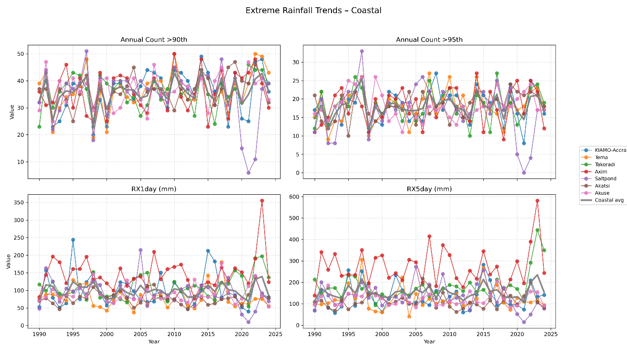

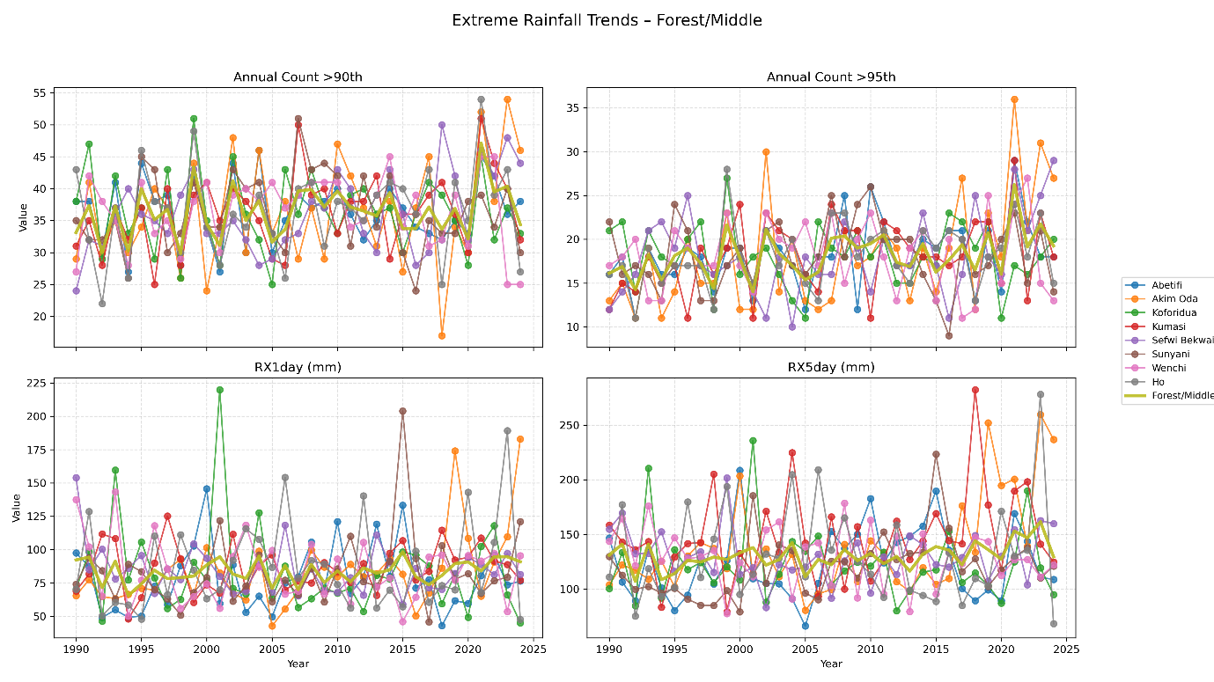

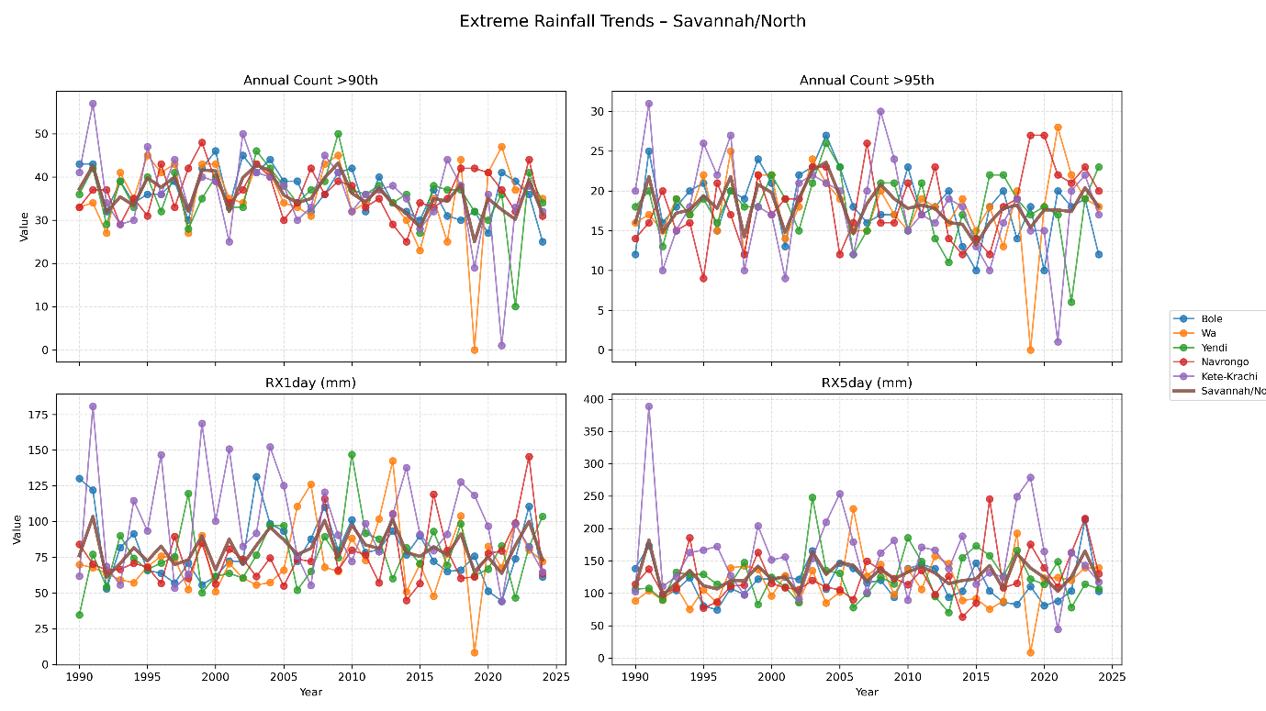

4.1.2 Spatial Trends in Extreme Precipitation (Sen’s Slope Analysis) 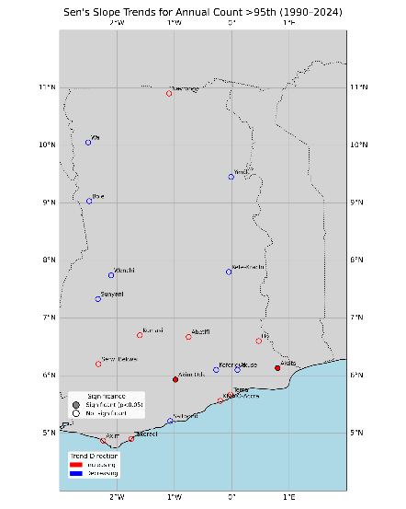 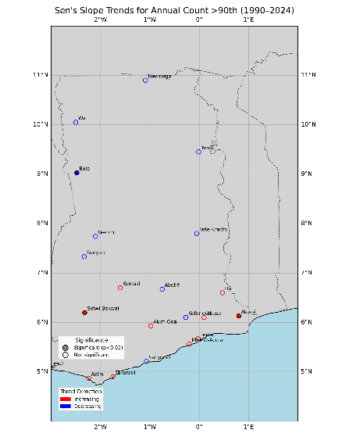

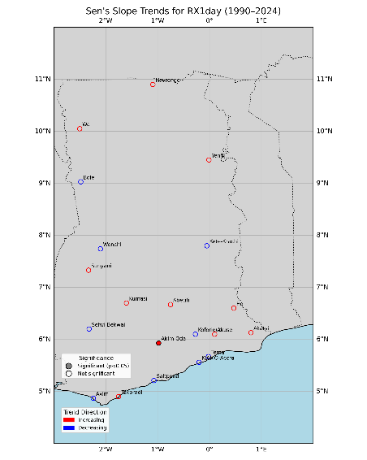 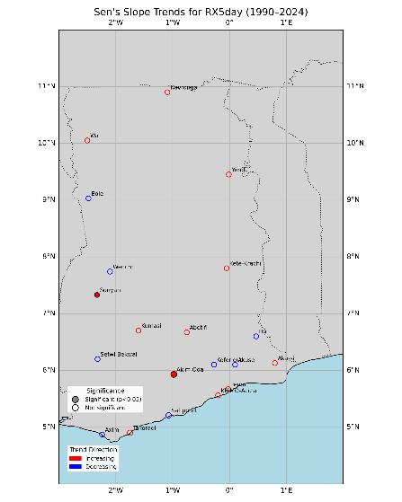

Figure 4.4 to 4.8 present the spatial distribution of Sen’s slope estimates for extreme precipitation indices over the period 1990–2024. The plots show both the direction of change (increasing vs. decreasing), and the statistical significance of the trends (p < 0.05). Together, these maps provide a national-scale perspective on the long-term evolution of extreme rainfall in Ghana.

For the **annual count of extreme rainfall days above the 90th percentile**, several stations in the coastal and forest belts exhibit positive Sen’s slope values, indicating an upward tendency in the frequency of moderate extremes. Notably, stations such as Ho, Akatsi, and Sefwi Bekwai recorded statistically significant increases, underscoring localized intensification in extreme day frequency. By contrast, most northern stations (Bole, Navrongo, Yendi) show negative or near-zero slopes, pointing to declining or stable counts of extremes in the savannah zone.

When considering **exceedances above the 95th percentile**, a similar pattern emerges, although the signal is less spatially consistent. Positive slopes are concentrated in the southern sector (Accra, Tema, Akatsi, Akim Oda), whereas the northern zone again shows declining trends. Importantly, many of these changes are not statistically significant, reflecting the large interannual variability that characterizes rainfall in West Africa.

The **magnitude-based indices (RX1day and RX5day)** further reinforce the spatial gradient. Increasing trends in RX1day are observed across much of the south, particularly around Ho, Akatsi, and Accra, although statistical significance remains limited. RX5day trends show a clearer zonal contrast: several forest and coastal stations (e.g., Sefwi Bekwai, Akim Oda, Accra) indicate significant increases in multi-day extremes, whereas most northern stations display weak or negative slopes. This suggests a strengthening of high-intensity, flood-prone rainfall events in the southern half of the country.

Overall, the Sen’s slope analysis highlights a **south–north gradient in extreme precipitation trends**. The **southern coastal and forest zones** exhibit more frequent and intense extremes, with several stations showing statistically significant increases, while the **northern savannah** is characterized by mixed or declining trends. This finding is consistent with earlier studies that documented a relative intensification of heavy rainfall along the Gulf of Guinea, in contrast to the more drought-prone conditions of northern Ghana. The spatial divergence has important implications for regional planning: coastal urban centers face growing flood risks, while the northern savannah continues to struggle with rainfall deficits and variability.

4.1.3 Decadal Variability and Return Periods of Extreme Rainfall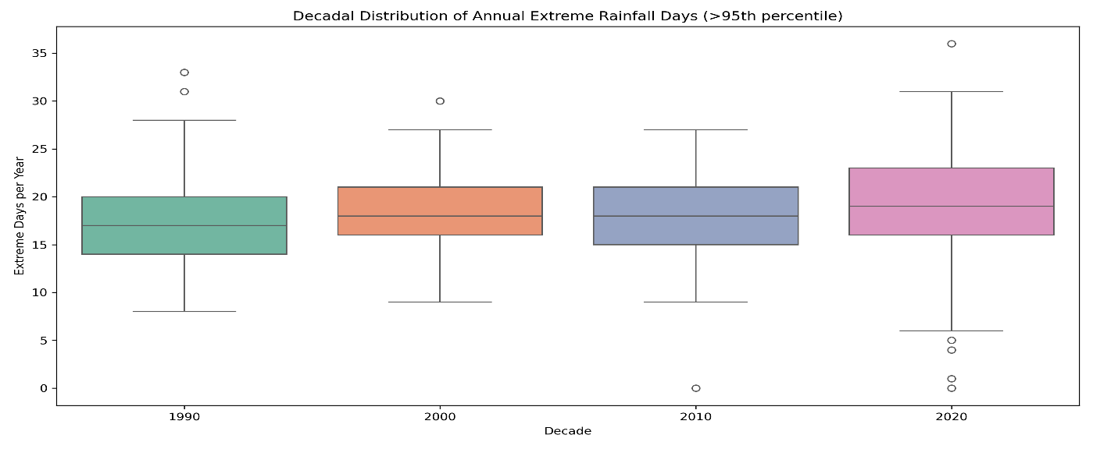

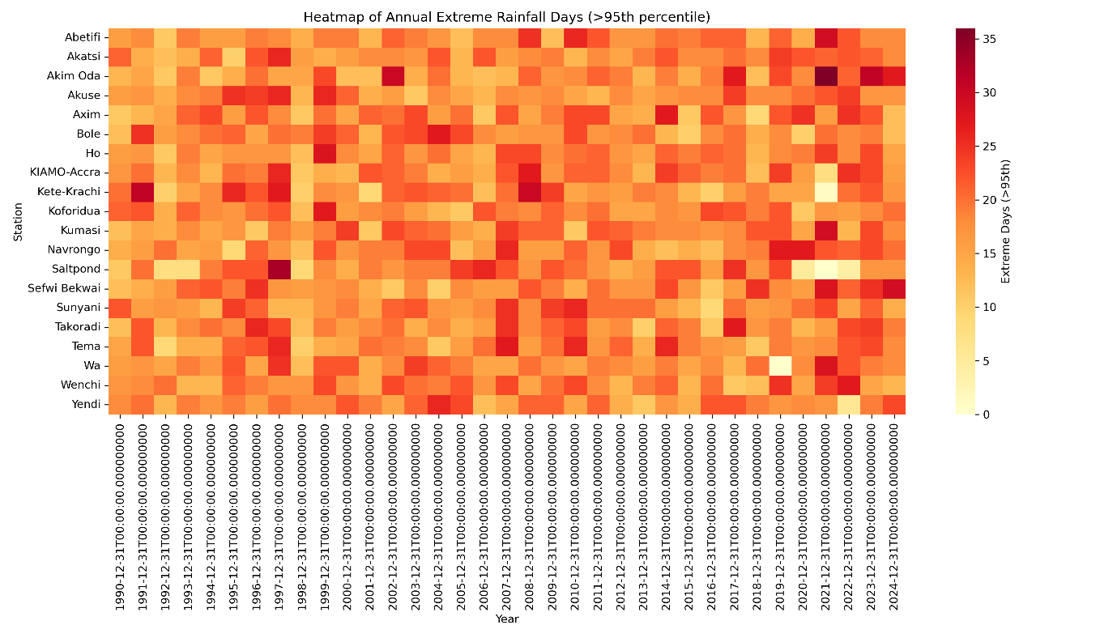

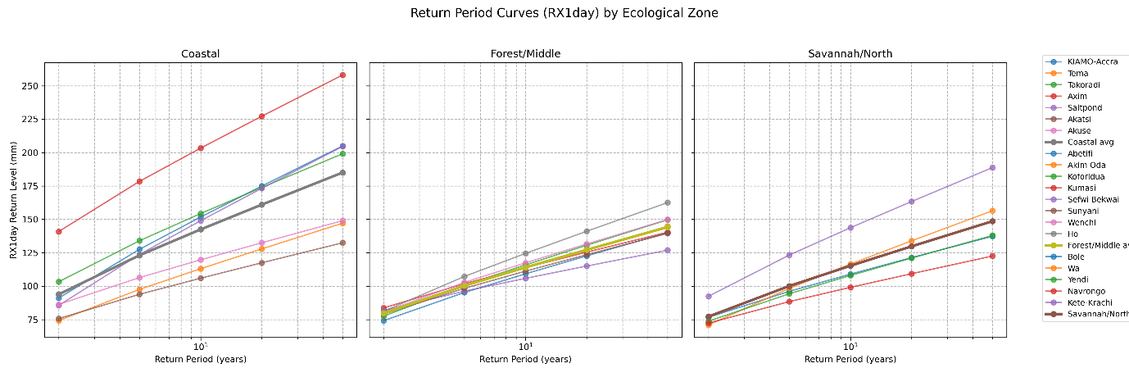

The decadal distribution of extreme rainfall days (Figure 4.9) reveals a gradual upward shift in the central tendency of extremes from the 1990s through the 2020s. Median values in the 1990s were around 17 days per year, rising to nearly 19–20 days in the most recent decade. The interquartile range has also broadened, suggesting greater variability in the frequency of extremes in recent decades. Although the overall increase is modest, the presence of more frequent high outliers in the 2010s and 2020s underscores the growing occurrence of particularly wet years, consistent with intensification signals observed in the coastal and forest zones. This aligns with other West African studies reporting increases in heavy rainfall events despite a relatively stable or declining annual mean rainfall.

The spatiotemporal distribution of extremes is further highlighted in the heatmap (Figure 4.10). While year-to-year variability is evident at all stations, clusters of widespread extremes are apparent during certain years, such as 1991, 2007, 2010, and 2022. These coincide with years of documented floods in Ghana and the wider subregion, reinforcing the linkage between national disaster records and extreme rainfall diagnostics. The heatmap also reveals regional contrasts: coastal and forest stations (e.g., Takoradi, Ho, and Accra) frequently record higher extreme-day counts compared with the more variable northern stations such as Wa and Navrongo. Such heterogeneity underscores the role of local climatic and topographic factors in modulating extremes.

The magnitude of rare events, expressed as return levels of RX1day, demonstrates substantial zonal differences (Figure 4.11). Along the coast, return levels for 10-year events frequently exceed 150–200 mm, with some stations such as Axim projecting over 250 mm for 20-year return periods. By comparison, forest-zone stations cluster around 100–140 mm for 10-year return levels, while savannah stations generally range between 80–120 mm. Nonetheless, certain savannah locations (e.g., Kete-Krachi, Navrongo) display notably higher return levels than the zonal average, reflecting localized vulnerability to high-intensity rainfall. These findings confirm that the **coastal belt is most exposed to short-duration, high-intensity rainfall extremes**, while the **northern savannah remains vulnerable to less frequent but occasionally severe bursts**.

Taken together, the decadal boxplots, station-level heatmaps, and return-period curves provide strong evidence of a **changing risk profile for extreme rainfall in Ghana**. While interannual and interdecadal variability remains high, the data suggest a tendency toward more frequent and more intense extremes in recent decades, especially in the coastal zone. This corroborates the zonal and Sen’s slope analyses, painting a coherent picture of **increasing hydrometeorological risk in southern Ghana** and more heterogeneous trends in the north.

4.2 Seasonality of Extreme Precipitation Events

The seasonal cycle of extreme precipitation, defined here as rainfall events above the 95th percentile, is shown in Figures 4.12–4.14. The results reveal clear zonal and seasonal contrasts in the timing and frequency of extremes across Ghana’s agro-ecological zones.

The **monthly climatology by ecological zone** (Figure 4.12) indicates distinct rainfall regimes between the coastal, forest, and savannah belts. The coastal zone shows a pronounced **bimodal pattern**, with peaks in May–June and a secondary maximum in September–October, reflecting the well-known “major” and “minor” rainy seasons of the Gulf of Guinea. In contrast, the savannah zone exhibits a **unimodal distribution**, with extreme events concentrated between July and September, corresponding to the single rainy season of northern Ghana. The forest zone displays an intermediate pattern, with two peaks similar to the coast but less sharply defined. These differences highlight the importance of the West African Monsoon and its seasonal migration in shaping extreme rainfall climatology.

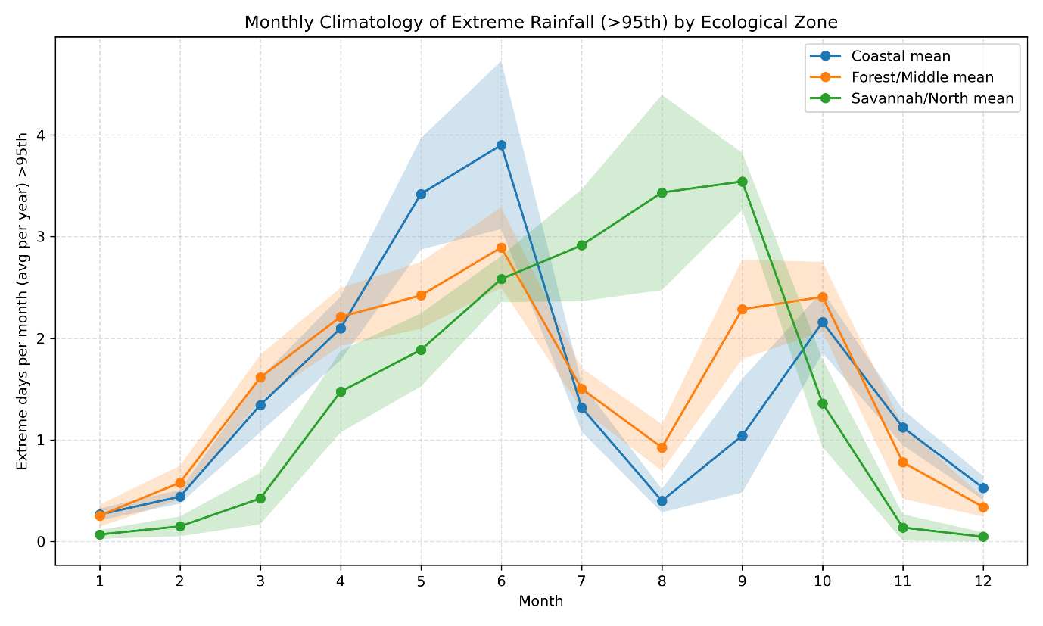

Also, figure 4.13 provide further statistical confirmation of these patterns. Extreme rainfall days are rare in December–February (DJF), which coincides with the dry season across Ghana. The highest frequencies occur during March–May (MAM) and June–August (JJA), with median values exceeding 5–7 extreme days per season. The September–November (SON) season maintains moderate counts, reflecting the minor rainy season in the south and the late monsoon rains in the north. This reinforces the central role of MAM and JJA as the peak seasons for extreme precipitation occurrence.

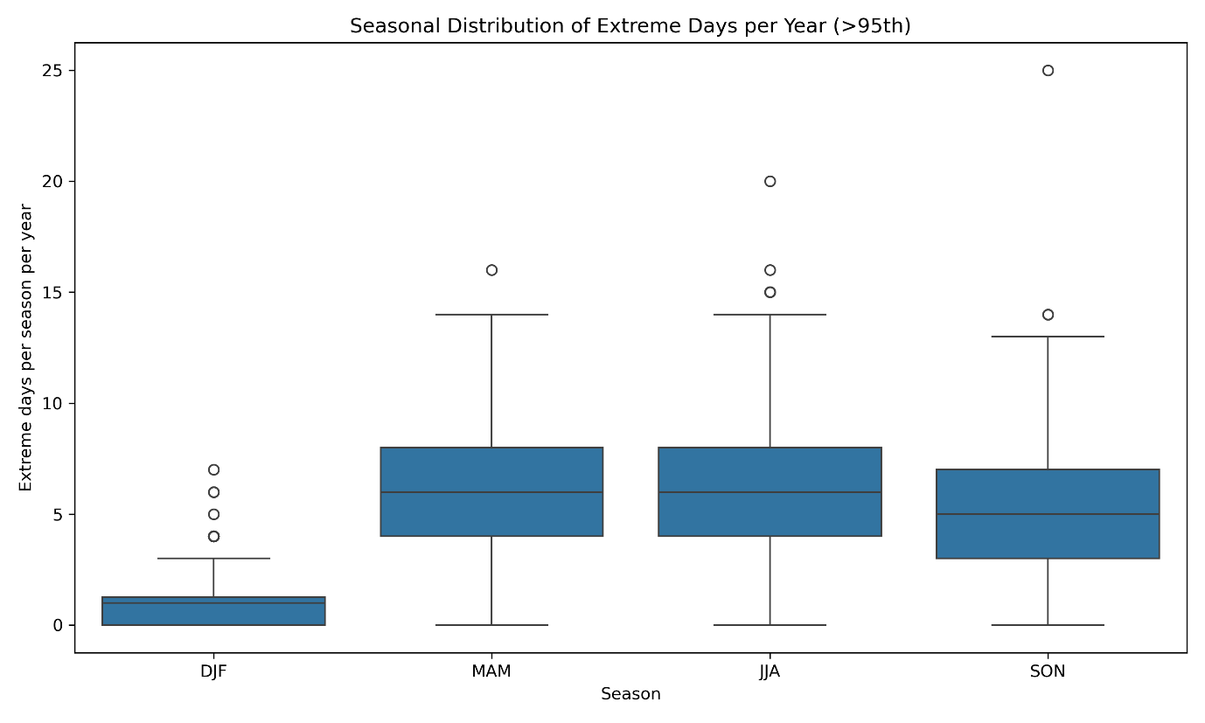

Figure 4.14, adds a finer spatial dimension to the seasonal cycle. Coastal stations such as Takoradi, Saltpond, and Accra register high frequencies of extremes in May–June and again in September, consistent with the bimodal coastal rainfall regime. In the forest zone, stations such as Kumasi and Ho show peaks in May–June with less consistent secondary maxima. Northern stations, particularly Navrongo and Wa, concentrate their extremes in July–September, in line with the unimodal monsoon-driven seasonality. The heatmap also highlights inter-station variability within zones, suggesting that local geographic features (e.g., orography, land–sea interactions) modulate the exact timing and intensity of extremes.

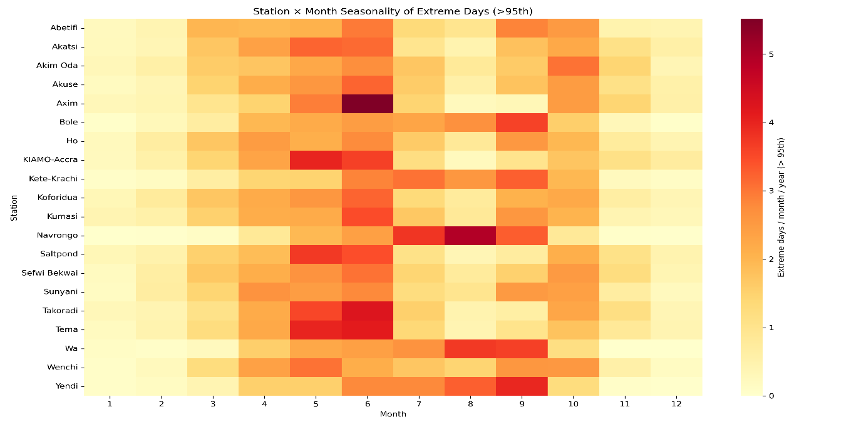

Overall, the seasonality analysis underscores that extreme rainfall in Ghana is **closely aligned with the broader seasonal rainfall regimes of the West African Monsoon system**. The results confirm that the **coastal zone experiences bimodal extreme rainfall peaks**, the **forest zone shows a transitional pattern**, and the **northern savannah is dominated by unimodal extremes**. This zonal differentiation has important implications for agriculture and water resource management, particularly in anticipating the timing of extreme rainfall hazards such as floods.

4.3 Influence of ENSO on Extreme Precipitation in Ghana

The relationship between ENSO variability and extreme precipitation in Ghana was explored using Niño 3.4 sea surface temperature anomalies and their classification into El Niño, La Niña, and Neutral phases. The results are summarized in Figures 4.15–4.17.

The **lagged correlation analysis** (Figure 4.15) indicates that ENSO anomalies are weakly but consistently related to the occurrence of extreme rainfall days. At zero lag, the correlation is slightly negative (r ≈ –0.02), suggesting that El Niño conditions tend to suppress extreme rainfall, while La Niña conditions tend to enhance them. Importantly, the correlation becomes progressively more negative when ENSO leads by 1–4 months, reaching its strongest values around a 4–5-month lead (r ≈ –0.08). This implies that ENSO anomalies in boreal spring and early summer may exert an influence on Ghana’s rainfall extremes during the main rainy season, consistent with the delayed teleconnection of ENSO on the West African monsoon system.

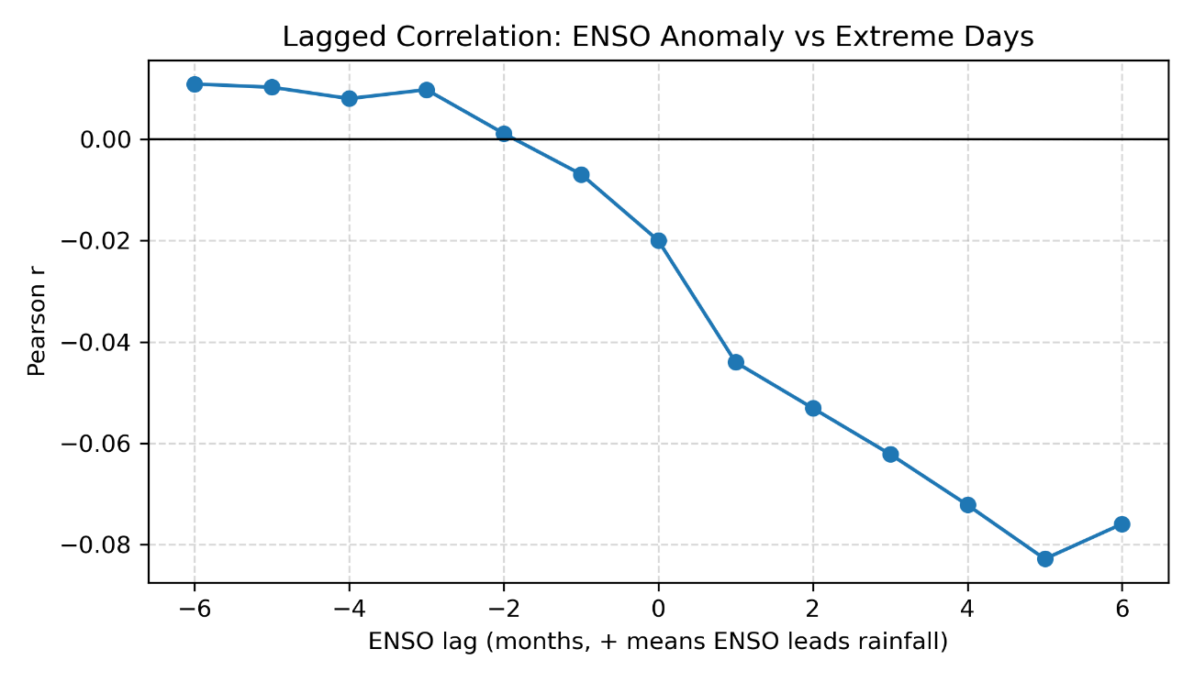

The **phase-based analysis** further supports this interpretation. The boxplots of extreme rainfall days by ENSO phase (Figure 4.16) show that **Neutral phases** are associated with the highest median number of extremes, followed by La Niña, with El Niño months recording the lowest extremes. The composite means (Figure 4.17) highlight that neutral months average approximately 35 extreme rainfall days (summed across all stations), compared to 26–27 days during La Niña and El Niño conditions. This asymmetry suggests that while ENSO influences extremes, its role is not deterministic; extremes can occur under all phases, but Neutral conditions appear most favorable for widespread rainfall extremes.

The relatively weak correlations underscore that the **ENSO–extreme rainfall link in Ghana is indirect and modulated by other regional drivers**, such as the Atlantic Niño, tropical Atlantic SST gradients, and the position of the Intertropical Convergence Zone (ITCZ). Nonetheless, the consistent negative correlation between ENSO anomalies and extreme rainfall frequency suggests that El Niño episodes generally suppress, while La Niña episodes tend to enhance, extreme rainfall over Ghana. These findings are in agreement with earlier studies (e.g., Joly & Voldoire, 2009; Nicholson, 2013), which noted ENSO’s influence on West African rainfall variability, albeit with stronger effects in the Sahel compared to the Guinea Coast.

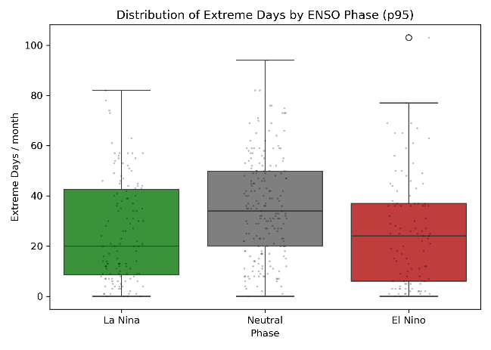 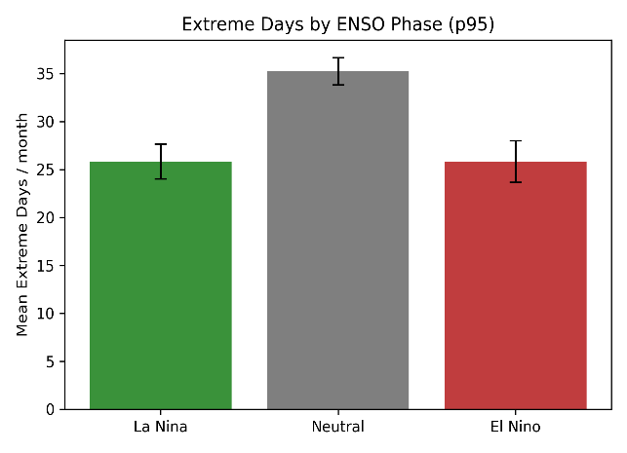

In practical terms, this analysis highlights the importance of considering **ENSO phase as a contributing but not dominant predictor** of extreme rainfall risk in Ghana. The observed lagged influence suggests that monitoring ENSO conditions several months ahead of the rainy season can provide useful early warning signals for hydrometeorological preparedness, especially when combined with regional Atlantic indices and local atmospheric predictors.

**CHAPTER FIVE: Conclusions and Recommendations**

**5.1 Conclusions**

This study examined the long-term variability, seasonal distribution, and large-scale drivers of extreme precipitation across 22 synoptic stations in Ghana over the period 1990–2024. The results demonstrate that extreme rainfall is highly variable both in time and space, yet consistent patterns emerge when the country is viewed across its three ecological zones. In terms of long-term trends, the analysis revealed that the frequency and intensity of extremes have increased more noticeably along the coastal and forest belts, where several stations recorded significant upward slopes in RX1day and RX5day indices. By contrast, the northern savannah generally exhibited flat or declining trends, reflecting its greater vulnerability to both drought and irregular bursts of intense rainfall. Return period analysis confirmed that the coastal zone is most exposed to high-intensity rainfall events, with 10-year RX1day levels commonly exceeding 150–200 mm, compared with 80–120 mm in the northern sector.

The seasonality of extremes closely aligns with the broader climatological regimes of the West African monsoon system. Coastal stations displayed a marked bimodal cycle, with peaks in May–June and September–October, while the savannah exhibited a unimodal distribution with extremes concentrated in July–September. The forest zone fell between these regimes, showing elements of both but with less sharply defined peaks. These patterns highlight the importance of MAM and JJA as the dominant seasons of extreme rainfall occurrence, carrying significant implications for agriculture, flood preparedness, and water resource management.

The influence of ENSO on Ghana’s extremes was found to be modest but consistent. El Niño conditions generally suppressed extremes while La Niña tended to enhance them, with the effect most apparent when ENSO anomalies led rainfall by about four to five months. Surprisingly, neutral ENSO conditions were associated with the highest number of extreme rainfall days, indicating that local and Atlantic drivers exert a stronger influence than ENSO alone. Overall, this study provides evidence that extremes are becoming more intense in southern Ghana, strongly modulated by seasonality, and partly influenced by ENSO, thereby underscoring the growing risks of hydrometeorological hazards in the country.

**5.2 Recommendations**

The findings carry important implications for policy, practice, and research. The increasing intensity of extremes along the coast calls for stronger urban flood preparedness, particularly in cities such as Accra and Takoradi where drainage, zoning, and early warning systems are already under pressure. In the forest and savannah zones, agricultural planning would benefit from aligning crop calendars with the observed timing of extremes, particularly the concentration of events during MAM and JJA. Extension services and local advisory programs should integrate seasonal forecasts of extremes to help farmers mitigate crop losses and optimize planting decisions. At the national scale, ENSO monitoring should be incorporated into early-warning frameworks, as anomalies detected in boreal spring may provide several months of lead time before the rainy season. Nonetheless, ENSO signals should be interpreted alongside Atlantic and regional climate indicators, which appear to play a stronger role in modulating Ghana’s rainfall extremes.

Future research should seek to integrate multiple large-scale drivers such as the Atlantic Niño, the Atlantic Meridional Mode, and the Sahel heat low in order to better explain interannual and decadal variability in extremes. High-resolution regional climate modeling is also needed to capture the influence of urbanization, land–sea interactions, and orographic effects on rainfall intensity. Finally, linking observed extremes to hydrological and socio-economic impacts would enhance the policy relevance of this work, while extending the analysis with satellite rainfall products and downscaling methods would strengthen the robustness of spatial coverage in areas with sparse station data.

# REFERENCES

Abbott, R., Abbott, T. D., Acernese, F., Ackley, K., Adams, C., Adhikari, N., Adhikari, R. X., Adya, V. B., Affeldt, C., Agarwal, D., Agathos, M., Agatsuma, K., Aggarwal, N., Aguiar, O. D., Aiello, L., Ain, A., Ajith, P., Akcay, S., Akutsu, T., . . . Bejger, M. (2024). GWTC-3: Compact Binary Coalescences Observed by LIGO and Virgo during the Second Part of the Third Observing Run. *Physical Review X*, *13*(4). <https://doi.org/10.1103/physrevx.13.04103>

Adams, D. K., & Comrie, A. C. (1997). The North American Monsoon. *Bulletin of the American Meteorological Society*, *78*(10), 2197–2213. <https://doi.org/10.1175/1520-0477(1997)07>

Adler, S. L., & Pais, P. (2019). Chiral anomaly calculation in the extended coupled Rarita-Schwinger model. *Physical Review. D/Physical Review. D.*, *99*(9). <https://doi.org/10.1103/physrevd.99.09503>

Agriculture Finance Diagnostic. (2019). In *World Bank, Washington, DC eBooks*. <https://doi.org/10.1596/33400>

Alam, K. M., & Saddik, A. E. (2017). C2PS: a digital twin architecture reference model for the Cloud-Based Cyber-Physical systems. *IEEE Access*, *5*, 2050–2062. <https://doi.org/10.1109/access.2017.2657006>

Alhaji, U. U., Yusuf, A. S., Edet, C. O., Oche, C. O., & Agbo, E. P. (2018). Trend analysis of temperature in Gombe State using Mann Kendall Trend Test. *Journal of Scientific Research and Reports*, *20*(3), 1–9. <https://doi.org/10.9734/jsrr/2018/42029>

Alkarkhi, A. F., & Alqaraghuli, W. A. (2019). R Statistical Software. In *Elsevier eBooks* (pp. 11–27). <https://doi.org/10.1016/b978-0-12-818622-0.00002-2>

Amikuzuno, J. (2009). *Spatial Price Transmission and Market Integration in Agricultural Markets after Liberalization in Ghana: Evidence from Fresh Tomato Markets*. <https://doi.org/10.53846/goediss-1672>

Angelakis, A. N., Capodaglio, A. G., Valipour, M., Krasilnikoff, J., Ahmed, A. T., Mandi, L., Tzanakakis, V. A., Baba, A., Kumar, R., Zheng, X., Min, Z., Han, M., Turay, B., Bilgiç, E., & Dercas, N. (2024). Evolution of Floods: From Ancient Times to the Present Times (ca 7600 BC to the Present) and the Future. *Land*, *12*(6), 1211. <https://doi.org/10.3390/land12061211>

Arnold, K., Golino, D. A., & McRoberts, N. (2016). A synoptic analysis of the temporal and spatial aspects of grapevine leafroll disease in a historic Napa vineyard and experimental vine blocks. *Phytopathology*, *107*(4), 418–426. <https://doi.org/10.1094/phyto-06-16-0235-r>

Ayanlade, A., Radeny, M., Morton, J. F., & Muchaba, T. (2018). Rainfall variability and drought characteristics in two agro-climatic zones: An assessment of climate change challenges in Africa. *The Science of the Total Environment*, *630*, 728–737. <https://doi.org/10.1016/j.scitotenv.2018.02.196>

Azumah, S. B., Donkoh, S. A., & Ansah, I. G. K. (2016). Contract farming and the adoption of climate change coping and adaptation strategies in the northern region of Ghana. *Environment Development and Sustainability*, *19*(6), 2275–2295. <https://doi.org/10.1007/s10668-016-9854-z>

Bai, X., McPhearson, T., Cleugh, H., Nagendra, H., Tong, X., Zhu, T., & Zhu, Y. (2017). Linking Urbanization and the Environment: Conceptual and Empirical advances. *Annual Review of Environment and Resources*, *42*(1), 215–240. <https://doi.org/10.1146/annurev-environ-102016-061128>

Baldwin, M. P., Ayarzagüena, B., Birner, T., Butchart, N., Butler, A. H., Charlton‐Perez, A. J., Domeisen, D. I. V., Garfinkel, C. I., Garny, H., Gerber, E. P., Hegglin, M. I., Langematz, U., & Pedatella, N. M. (2020). Sudden stratospheric warmings. *Reviews of Geophysics*, *59*(1). <https://doi.org/10.1029/2020rg000708>

Barriopedro, D., García‐Herrera, R., Ordóñez, C., Miralles, D. G., & Salcedo‐Sanz, S. (2024a). Heat waves: physical understanding and scientific challenges. *Reviews of Geophysics*, *61*(2). <https://doi.org/10.1029/2022rg000780>

Barriopedro, D., García‐Herrera, R., Ordóñez, C., Miralles, D. G., & Salcedo‐Sanz, S. (2024b). Heat waves: physical understanding and scientific challenges. *Reviews of Geophysics*, *61*(2). <https://doi.org/10.1029/2022rg000780>

Barriopedro, D., García‐Herrera, R., Ordóñez, C., Miralles, D. G., & Salcedo‐Sanz, S. (2024c). Heat waves: physical understanding and scientific challenges. *Reviews of Geophysics*, *61*(2). <https://doi.org/10.1029/2022rg000780>

Bauer, G. R., & Scheim, A. I. (2019). Advancing quantitative intersectionality research methods: Intracategorical and intercategorical approaches to shared and differential constructs. *Social Science & Medicine*, *226*, 260–262. <https://doi.org/10.1016/j.socscimed.2019.03.018>

Bello, O., De Meira, L. F., Gonzales, C., Peralta, L., Skerette, N., Marcano, B., Patin, M., Vivas, G., Espiga, C., Allen, E., Ruiz, E., Ibarra, F., Espiga, F., Gonzalez, M., Marconi, S., Carrera, D., Nelson, M., Chakalall, Y., Perroni, A., . . . Mason, M. (2020). *Assessment of the effects and impacts of Hurricane Dorian in the Bahamas*. <https://doi.org/10.18235/0002582>

Bhatti, A. S., Wang, G., Ullah, W., Ullah, S., Hagan, D. F. T., Nooni, I. K., Lou, D., & Ullah, I. (2020). Trend in Extreme Precipitation Indices Based on Long Term In Situ Precipitation Records over Pakistan. *Water*, *12*(3), 797. <https://doi.org/10.3390/w12030797>

Bob, N. K. (2013). Value at risk Estimation A GARCH-EVT-Copula approach. *Extreme Value Theory, Specifically the Gumbel Distribution,*. <http://www2.math.su.se/matstat/reports/master/2013/rep6/report.pdf>

Bony, S., Stevens, B., Frierson, D. M. W., Jakob, C., Kageyama, M., Pincus, R., Shepherd, T. G., Sherwood, S. C., Siebesma, A. P., Sobel, A. H., Watanabe, M., & Webb, M. J. (2015). Clouds, circulation and climate sensitivity. *Nature Geoscience*, *8*(4), 261–268. <https://doi.org/10.1038/ngeo2398>

Branstad-Spates, E. H. (2024). *Integrated mycotoxin risk management strategies for grain handling and feed manufacturing industries*. <https://doi.org/10.31274/td-20240329-434>

Brantley, S. L., McDowell, W. H., Dietrich, W. E., White, T. S., Kumar, P., Anderson, S. P., Chorover, J., Lohse, K. A., Bales, R. C., Richter, D. D., Grant, G., & Gaillardet, J. (2017). Designing a network of critical zone observatories to explore the living skin of the terrestrial Earth. *Earth Surface Dynamics*, *5*(4), 841–860. <https://doi.org/10.5194/esurf-5-841-2017>

Calvin, K., Dasgupta, D., Krinner, G., Mukherji, A., Thorne, P. W., Trisos, C., Romero, J., Aldunce, P., Barrett, K., Blanco, G., Cheung, W. W., Connors, S., Denton, F., Diongue-Niang, A., Dodman, D., Garschagen, M., Geden, O., Hayward, B., Jones, C., . . . Ha, M. (2024a). *IPCC, 2024: Climate Change 2024: Synthesis Report. Contribution of Working Groups I, II and III to the Sixth Assessment Report of the Intergovernmental Panel on Climate Change [Core Writing Team, H. Lee and J. Romero (eds.)]. IPCC, Geneva, Switzerland.* <https://doi.org/10.59327/ipcc/ar6-9789291691647>

Calvin, K., Dasgupta, D., Krinner, G., Mukherji, A., Thorne, P. W., Trisos, C., Romero, J., Aldunce, P., Barrett, K., Blanco, G., Cheung, W. W., Connors, S., Denton, F., Diongue-Niang, A., Dodman, D., Garschagen, M., Geden, O., Hayward, B., Jones, C., . . . Ha, M. (2024b). *IPCC, 2024: Climate Change 2024: Synthesis Report. Contribution of Working Groups I, II and III to the Sixth Assessment Report of the Intergovernmental Panel on Climate Change [Core Writing Team, H. Lee and J. Romero (eds.)]. IPCC, Geneva, Switzerland.* <https://doi.org/10.59327/ipcc/ar6-9789291691647>

Capotondi, A., Wittenberg, A. T., Newman, M., Di Lorenzo, E., Yu, J., Braconnot, P., Cole, J., Dewitte, B., Giese, B., Guilyardi, E., Jin, F., Karnauskas, K., Kirtman, B., Lee, T., Schneider, N., Xue, Y., & Yeh, S. (2014). Understanding ENSO diversity. *Bulletin of the American Meteorological Society*, *96*(6), 921–938. <https://doi.org/10.1175/bams-d-13-00117.1>

Cattani, E., Merino, A., Guijarro, J., & Levizzani, V. (2018). East Africa Rainfall Trends and Variability 1983–2015 using three Long-Term Satellite products. *Remote Sensing*, *10*(6), 931. <https://doi.org/10.3390/rs10060931>

Chen, H., & Jin, F. (2019). Fundamental behavior of ENSO phase locking. *Journal of Climate*, *33*(5), 1953–1968. <https://doi.org/10.1175/jcli-d-19-0264.1>

Chen, H., Liu, Y., Chiang, C., Liu, X., Chou, Y., & Pan, H. (2019). China’s historical record when searching for tropical cyclones corresponding to Intertropical Convergence Zone (ITCZ) shifts over the past 2 kyr. *Climate of the Past*, *15*(1), 279–289. https://doi.org/10.5194/cp-15-279-2019

Chen, L., Han, B., Wang, X., Zhao, J., Yang, W., & Yang, Z. (2024a). Machine Learning Methods in Weather and Climate Applications: a survey. *Applied Sciences*, *13*(21), 12019. <https://doi.org/10.3390/app132112019>

Chen, L., Han, B., Wang, X., Zhao, J., Yang, W., & Yang, Z. (2024b). Machine Learning Methods in Weather and Climate Applications: a survey. *Applied Sciences*, *13*(21), 12019. <https://doi.org/10.3390/app132112019>

Cheng, L., & Zhang, Y. (2022). Do able managers take more risks? *Journal of Innovation & Knowledge*, *7*(2), 100182. <https://doi.org/10.1016/j.jik.2022.100182>

Chitando, E., Conradie, E. M., & Kilonzo, S. M. (2022). African perspectives on religion and climate change. In *Routledge eBooks*. <https://doi.org/10.4324/9781003147909>

Chuvieco, E., Mouillot, F., Van Der Werf, G. R., Miguel, J. S., Tanase, M., Koutsias, N., García, M., Yebra, M., Padilla, M., Gitas, I., Heil, A., Hawbaker, T. J., & Giglio, L. (2019). Historical background and current developments for mapping burned area from satellite Earth observation. *Remote Sensing of Environment*, *225*, 45–64. <https://doi.org/10.1016/j.rse.2019.02.013>

Clavin, C. T., Petropoulos, Z. E., Gupta, N., & Tokita, C. K. (2017). *Case Studies of Community Resilience and Disaster Recovery from the 2013 Boulder County Floods*. <https://doi.org/10.6028/nist.gcr.16-011>

*Climate Change 2014 - Synthesis Report*. (2015). <https://doi.org/10.59327/ipcc/ar5-9789291691432>

Cohen, L. E., & Felson, M. (1979). Social Change and Crime Rate Trends: A Routine Activity approach. *American Sociological Review*, *44*(4), 588. <https://doi.org/10.2307/2094589>

Collins, M., Sutherland, M., Bouwer, L., Cheong, S., Frölicher, T., Jacot, H., Combes, D., Koll, M., Losada, I., Mcinnes, K., Australia, E., Rivera-Arriaga, R., Susanto, I., Tibig, L., Bakker, P., Mark, C., Emanuel, K., Grose, M., Hemer, M., . . . Zhai, P. (2022a). Extremes, abrupt changes and managing risks. In *Cambridge University Press eBooks* (pp. 589–656). <https://doi.org/10.1017/9781009157964.008>

Collins, M., Sutherland, M., Bouwer, L., Cheong, S., Frölicher, T., Jacot, H., Combes, D., Koll, M., Losada, I., Mcinnes, K., Australia, E., Rivera-Arriaga, R., Susanto, I., Tibig, L., Bakker, P., Mark, C., Emanuel, K., Grose, M., Hemer, M., . . . Zhai, P. (2022b). Extremes, abrupt changes and managing risks. In *Cambridge University Press eBooks* (pp. 589–656). <https://doi.org/10.1017/9781009157964.008>

Cordeiro, G. M., Nadarajah, S., & Ortega, E. M. M. (2011). The Kumaraswamy Gumbel distribution. *Statistical Methods & Applications*, *21*(2), 139–168. <https://doi.org/10.1007/s10260-011-0183-y>

Cradock-Henry, N. A. (2021). Linking the social, economic, and agroecological: a resilience framework for dairy farming. *Ecology and Society*, *26*(1). <https://doi.org/10.5751/es-12122-260103>

Dallas, H. F., & Rivers-Moore, N. (2014). Ecological consequences of global climate change for freshwater ecosystems in South Africa. *South African Journal of Science*, *110*(5/6), 11. <https://doi.org/10.1590/sajs.2014/20130274>

Dapilah, F., Nielsen, J. Ø., & Friis, C. (2019). The role of social networks in building adaptive capacity and resilience to climate change: a case study from northern Ghana. *Climate and Development*, *12*(1), 42–56. <https://doi.org/10.1080/17565529.2019.1596063>

De La Fuente, A., Navarro, A., & Williams, S. E. (2024). The climatic drivers of long‐term population changes in rainforest montane birds. *Global Change Biology*, *29*(8), 2132–2140. <https://doi.org/10.1111/gcb.16608>

De Paiva, R. C. D., Chaffe, P. L. B., Anache, J. a. A., Fontes, A. S., De Araujo, L. M. N., De Araujo, A. N., Bartiko, D., Bleninger, T., De Amorim, P. B., Buarque, D. C., Carlotto, T., Collischonn, W., Detzel, D. H. M., Fan, F. M., Formiga-Johnsson, R. M., Kobiyama, M., Mannich, M., Marques, G., Michel, G. P., . . . Zanandrea, F. (2020). Advances and challenges in the water sciences in Brazil: a community synthesis of the XXIII Brazilian Water Resources Symposium. *RBRH*, *25*. <https://doi.org/10.1590/2318-0331.252020200136>

De Vries, A. J. (2021). A global climatological perspective on the importance of Rossby wave breaking and intense moisture transport for extreme precipitation events. *Weather and Climate Dynamics*, *2*(1), 129–161. <https://doi.org/10.5194/wcd-2-129-2021>

Dell, M., Jones, B. F., & Olken, B. A. (2014). What Do We Learn from the Weather? The New Climate-Economy Literature. *Journal of Economic Literature*, *52*(3), 740–798. <https://doi.org/10.1257/jel.52.3.740>

Dieng, D., Smiatek, G., Heinzeller, D., & Kunstmann, H. (2016). Simulation of the Rain Belt of the West African Monsoon (WAM) in high resolution CCLM simulation. In *Springer eBooks* (pp. 547–558). <https://doi.org/10.1007/978-3-319-47066-5_37>

Djamali, M., Akhani, H., Andrieu-Ponel, V., Braconnot, P., Brewer, S., De Beaulieu, J., Fleitmann, D., Fleury, J., Gasse, F., Guibal, F., Jackson, S. T., Lézine, A., Médail, F., Ponel, P., Roberts, N., & Stevens, L. (2010). Indian Summer Monsoon variations could have affected the early-Holocene woodland expansion in the Near East. *The Holocene*, *20*(5), 813–820. <https://doi.org/10.1177/0959683610362813>

Dorigo, W., Wagner, W., Albergel, C., Albrecht, F., Balsamo, G., Brocca, L., Chung, D., Ertl, M., Forkel, M., Gruber, A., Haas, E., Hamer, P. D., Hirschi, M., Ikonen, J., De Jeu, R., Kidd, R., Lahoz, W., Liu, Y. Y., Miralles, D., . . . Lecomte, P. (2017). ESA CCI Soil Moisture for improved Earth system understanding: State-of-the art and future directions. *Remote Sensing of Environment*, *203*, 185–215. <https://doi.org/10.1016/j.rse.2017.07.001>

Döring, S. (2019). Come rain, or come wells: How access to groundwater affects communal violence. *Political Geography*, *76*, 102073. <https://doi.org/10.1016/j.polgeo.2019.102073>

Dubash, N. K., Mitchell, C., Boasson, E. L., Córdova, M. J. B., Fifita, S., Haites, E., Jaccard, M., Jotzo, F., Naidoo, S., Romero-Lankao, P., Shlapak, M., Shen, W., Wu, L., Aasen, M., Bashmakov, I., Bhatia, P., Bertoldi, P., Boykoff, M., Britton, J., . . . Tosun, J. (2024). National and sub-national policies and institutions. In *Cambridge University Press eBooks* (pp. 1355–1450). <https://doi.org/10.1017/9781009157926.015>

Dunn, R. J. H., Herold, N., Alexander, L. V., Donat, M. G., Allan, R., Bador, M., Brunet, M., Cheng, V., Ibadullah, W. M. W., Ibrahim, M. K. I. B., Kruger, A., Kubota, H., Lippmann, T. J. R., Marengo, J., Mbatha, S., McGree, S., Ngwenya, S., Caicedo, J. D. P., Ramos, A., . . . Zhang, X. (2024). Observed Global Changes in Sector‐Relevant Climate Extremes Indices—An extension to HADEX3. *Earth and Space Science*, *11*(4). [https://doi.org/10.1029/2024ea003279](https://doi.org/10.1029/2023ea003279)

Dwivedi, Y. K., Hughes, L., Ismagilova, E., Aarts, G., Coombs, C., Crick, T., Duan, Y., Dwivedi, R., Edwards, J., Eirug, A., Galanos, V., Ilavarasan, P. V., Janssen, M., Jones, P., Kar, A. K., Kizgin, H., Kronemann, B., Lal, B., Lucini, B., . . . Williams, M. D. (2019). Artificial Intelligence (AI): Multidisciplinary perspectives on emerging challenges, opportunities, and agenda for research, practice and policy. *International Journal of Information Management*, *57*, 101994. <https://doi.org/10.1016/j.ijinfomgt.2019.08.002>

Evans, C., Wood, K. M., Aberson, S. D., Archambault, H. M., Milrad, S. M., Bosart, L. F., Corbosiero, K. L., Davis, C. A., Pinto, J. R. D., Doyle, J., Fogarty, C., Galarneau, T. J., Grams, C. M., Griffin, K. S., Gyakum, J., Hart, R. E., Kitabatake, N., Lentink, H. S., McTaggart-Cowan, R., . . . Zhang, F. (2017). The Extratropical Transition of Tropical Cyclones. Part I: Cyclone evolution and Direct Impacts. *Monthly Weather Review*, *145*(11), 4317–4344. <https://doi.org/10.1175/mwr-d-17-0027.1>

Fan, X., Scaringi, G., Korup, O., West, A. J., Van Westen, C. J., Tanyas, H., Hovius, N., Hales, T. C., Jibson, R. W., Allstadt, K. E., Zhang, L., Evans, S. G., Xu, C., Li, G., Pei, X., Xu, Q., & Huang, R. (2019). Earthquake‐Induced Chains of Geologic Hazards: Patterns, mechanisms, and impacts. *Reviews of Geophysics*, *57*(2), 421–503. <https://doi.org/10.1029/2018rg000626>

Flaounas, E., Davolio, S., Raveh-Rubin, S., Pantillon, F., Miglietta, M. M., Gaertner, M. A., Hatzaki, M., Homar, V., Khodayar, S., Korres, G., Kotroni, V., Kushta, J., Reale, M., & Ricard, D. (2022). Mediterranean cyclones: current knowledge and open questions on dynamics, prediction, climatology and impacts. *Weather and Climate Dynamics*, *3*(1), 173–208. <https://doi.org/10.5194/wcd-3-173-2022>

Friedlingstein, P., Jones, M. W., O’Sullivan, M., Andrew, R. M., Bakker, D. C. E., Hauck, J., Quéré, C. L., Peters, G. P., Peters, W., Pongratz, J., Sitch, S., Canadell, J. G., Ciais, P., Jackson, R. B., Alin, S. R., Anthoni, P., Bates, N. R., Becker, M., Bellouin, N., . . . Zeng, J. (2022). Global Carbon Budget 2021. *Earth System Science Data*, *14*(4), 1917–2005. <https://doi.org/10.5194/essd-14-1917-2022>

Friedlingstein, P., O’Sullivan, M., Jones, M. W., Andrew, R. M., Gregor, L., Hauck, J., Quéré, C. L., Luijkx, I. T., Olsen, A., Peters, G. P., Peters, W., Pongratz, J., Schwingshackl, C., Sitch, S., Canadell, J. G., Ciais, P., Jackson, R. B., Alin, S. R., Alkama, R., . . . Wright, R. (2022). Global Carbon Budget 2022. *Earth System Science Data*, *14*(11), 4811–4900. <https://doi.org/10.5194/essd-14-4811-2022>

Frischer, B., Pollini, J., Capriotti, G., Murray, J., Swetnam-Burland, M., Galinsky, K., Häuber, C., Miller, J., Salzman, M., Fillwalk, J., & Brennan, M. (2017). New Light on the Relationship between the Montecitorio Obelisk and Ara Pacis of Augustus. *Studies in Digital Heritage*, *1*(1), 18–119. <https://doi.org/10.14434/sdh.v1i1.23331>

Froude, M. J., & Petley, D. N. (2018). Global fatal landslide occurrence from 2004 to 2016. *Natural Hazards and Earth System Sciences*, *18*(8), 2161–2181. <https://doi.org/10.5194/nhess-18-2161-2018>

Funk, C., Shukla, S., Thiaw, W. M., Rowland, J., Hoell, A., McNally, A., Husak, G., Novella, N., Budde, M., Peters-Lidard, C., Adoum, A., Galu, G., Korecha, D., Magadzire, T., Rodriguez, M., Robjhon, M., Bekele, E., Arsenault, K., Peterson, P., . . . Verdin, J. (2019). Recognizing the Famine Early Warning Systems Network: Over 30 years of drought early warning science advances and partnerships promoting global food security. *Bulletin of the American Meteorological Society*, *100*(6), 1011–1027. <https://doi.org/10.1175/bams-d-17-0233.1>

Ganguli, P., & Coulibaly, P. (2017). Does nonstationarity in rainfall require nonstationary intensity–duration–frequency curves? *Hydrology and Earth System Sciences*, *21*(12), 6461–6483. <https://doi.org/10.5194/hess-21-6461-2017>

Gann, G. D., McDonald, T., Walder, B., Aronson, J., Nelson, C. R., Jonson, J., Hallett, J. G., Eisenberg, C., Guariguata, M. R., Liu, J., Hua, F., Echeverría, C., Gonzales, E., Shaw, N., Decleer, K., & Dixon, K. W. (2019). International principles and standards for the practice of ecological restoration. Second edition. *Restoration Ecology*, *27*(S1). <https://doi.org/10.1111/rec.13035>

Garreaud, R. D., Alvarez-Garreton, C., Barichivich, J., Boisier, J. P., Christie, D., Galleguillos, M., LeQuesne, C., McPhee, J., & Zambrano-Bigiarini, M. (2017). The 2010–2015 megadrought in central Chile: impacts on regional hydroclimate and vegetation. *Hydrology and Earth System Sciences*, *21*(12), 6307–6327. <https://doi.org/10.5194/hess-21-6307-2017>

Geen, R., Bordoni, S., Battisti, D. S., & Hui, K. (2020a). Monsoons, ITCZs, and the concept of the global monsoon. *Reviews of Geophysics*, *58*(4). https://doi.org/10.1029/2020rg000700

Geen, R., Bordoni, S., Battisti, D. S., & Hui, K. (2020b). Monsoons, ITCZs, and the concept of the global monsoon. *Reviews of Geophysics*, *58*(4). <https://doi.org/10.1029/2020rg000700>

Gidhagen, L., Olsson, J., Amorim, J. H., Asker, C., Belusic, D., Carvalho, A. C., Engardt, M., Hundecha, Y., Körnich, H., Lind, P., Lindstedt, D., Olsson, E., Rosberg, J., Segersson, D., & Strömbäck, L. (2019). Towards climate services for European cities: Lessons learnt from the Copernicus project Urban SIS. *Urban Climate*, *31*, 100549. <https://doi.org/10.1016/j.uclim.2019.100549>

Giorgi, F. (2019). Thirty Years of Regional Climate Modeling: Where Are We and Where Are We Going next? *Journal of Geophysical Research Atmospheres*, *124*(11), 5696–5723. <https://doi.org/10.1029/2018jd030094>

Global Security risks and West Africa. (2012). In *West African studies*. <https://doi.org/10.1787/9789264171848-en>

Glotzer, S. C., Kim, S., Cummings, P. T., Deshmukh, A., Head-Gordon, M., Karniadakis, G., Petzold, L., Sagui, C., & Shinozuka, M. (2013). *WTEC Panel Report on International Assessment of Research and Development in Simulation-Based Engineering and Science*. <https://doi.org/10.2172/108884>

González, J. E., Ortiz, L., Smith, B. K., Devineni, N., Colle, B., Booth, J. F., Ravindranath, A., Rivera, L., Horton, R., Towey, K., Kushnir, Y., Manley, D., Bader, D., & Rosenzweig, C. (2019). New York City Panel on Climate Change 2019 Report Chapter 2: New methods for assessing extreme temperatures, heavy downpours, and drought. *Annals of the New York Academy of Sciences*, *1439*(1), 30–70. <https://doi.org/10.1111/nyas.14007>

Goodson, L., & Phillimore, J. (2004). Qualitative research in tourism. In *Routledge eBooks*. <https://doi.org/10.4324/9780203642986>

Goswami, B. B., Mukhopadhyay, P., Mahanta, R., & Goswami, B. N. (2010). Multiscale interaction with topography and extreme rainfall events in the northeast Indian region. *Journal of Geophysical Research Atmospheres*, *115*(D12). <https://doi.org/10.1029/2009jd012275>

Grote, U., Fasse, A., Nguyen, T. T., & Erenstein, O. (2021). Food security and the dynamics of wheat and maize value chains in Africa and Asia. *Frontiers in Sustainable Food Systems*, *4*. <https://doi.org/10.3389/fsufs.2020.617009>

Hagenlocher, M., Meza, I., Anderson, C. C., Min, A., Renaud, F. G., Walz, Y., Siebert, S., & Sebesvari, Z. (2019). Drought vulnerability and risk assessments: state of the art, persistent gaps, and research agenda. *Environmental Research Letters*, *14*(8), 083002. <https://doi.org/10.1088/1748-9326/ab225d>

Hallegatte, S., Rentschler, J., & Rozenberg, J. (2019). Lifelines: the resilient infrastructure opportunity. In *Washington, DC: World Bank eBooks*. https://doi.org/10.1596/978-1-4648-1430-3

Hao, Z., Singh, V. P., & Xia, Y. (2018). Seasonal Drought prediction: Advances, challenges, and future prospects. *Reviews of Geophysics*, *56*(1), 108–141. <https://doi.org/10.1002/2016rg000549>

Heckmann, T., Cavalli, M., Cerdan, O., Foerster, S., Javaux, M., Lode, E., Smetanová, A., Vericat, D., & Brardinoni, F. (2018). Indices of sediment connectivity: opportunities, challenges and limitations. *Earth-Science Reviews*, *187*, 77–108. <https://doi.org/10.1016/j.earscirev.2018.08.004>

Hegerl, G. C., Black, E., Allan, R. P., Ingram, W. J., Polson, D., Trenberth, K. E., Chadwick, R. S., Arkin, P. A., Sarojini, B. B., Becker, A., Dai, A., Durack, P. J., Easterling, D., Fowler, H. J., Kendon, E. J., Huffman, G. J., Liu, C., Marsh, R., New, M., . . . Zhang, X. (2014). Challenges in quantifying changes in the global water cycle. *Bulletin of the American Meteorological Society*, *96*(7), 1097–1115. <https://doi.org/10.1175/bams-d-13-00212.1>

Henrico, S., Coetzee, S., & Cooper, A. (2020). Is open source GIS feasible in military operations? Evaluation by applying a USE case. *Scientia Militaria South African Journal of Military Studies*. <https://doi.org/10.5787/48-1-1259>

Hounguè, N. R., Ogbu, K. N., Almoradie, A. D. S., & Evers, M. (2021). Evaluation of the performance of remotely sensed rainfall datasets for flood simulation in the transboundary Mono River catchment, Togo and Benin. *Journal of Hydrology Regional Studies*, *36*, 100875. <https://doi.org/10.1016/j.ejrh.2021.100875>

Inness, A., Ades, M., Agustí-Panareda, A., Barré, J., Benedictow, A., Blechschmidt, A., Dominguez, J. J., Engelen, R., Eskes, H., Flemming, J., Huijnen, V., Jones, L., Kipling, Z., Massart, S., Parrington, M., Peuch, V., Razinger, M., Remy, S., Schulz, M., & Suttie, M. (2019). The CAMS reanalysis of atmospheric composition. *Atmospheric Chemistry and Physics*, *19*(6), 3515–3556. <https://doi.org/10.5194/acp-19-3515-2019>

Islam, M. S., Ali, Y., Kabir, M. H., Zubaer, R. M., Meghla, N. T., Rehnuma, M., & Hoque, M. M. M. (2021). Assessment of temporal variation of water quality parameters and the Trophic State Index in a subtropical water reservoir of Bangladesh. *Grassroots Journal of Natural Resources*, *4*(3), 164–184. <https://doi.org/10.33002/nr2581.6853.040313>

Jean-Michel, L., Eric, G., Romain, B., Gilles, G., Angélique, M., Marie, D., Clément, B., Mathieu, H., Olivier, L. G., Charly, R., Tony, C., Charles-Emmanuel, T., Florent, G., Giovanni, R., Mounir, B., Yann, D., & Pierre-Yves, L. T. (2021). The Copernicus Global 1/12° Oceanic and Sea Ice GLORYS12 Reanalysis. *Frontiers in Earth Science*, *9*. <https://doi.org/10.3389/feart.2021.698876>

Jones, M. W., Abatzoglou, J. T., Veraverbeke, S., Andela, N., Lasslop, G., Forkel, M., Smith, A. J. P., Burton, C., Betts, R. A., Van Der Werf, G. R., Sitch, S., Canadell, J. G., Santín, C., Kolden, C., Doerr, S. H., & Quéré, C. L. (2022). Global and regional trends and drivers of fire under climate change. *Reviews of Geophysics*, *60*(3). <https://doi.org/10.1029/2020rg000726>

Jones, M. W., Kelley, D. I., Burton, C. A., Di Giuseppe, F., Barbosa, M. L. F., Brambleby, E., Hartley, A. J., Lombardi, A., Mataveli, G., McNorton, J. R., Spuler, F. R., Wessel, J. B., Abatzoglou, J. T., Anderson, L. O., Andela, N., Archibald, S., Armenteras, D., Burke, E., Carmenta, R., . . . Xanthopoulos, G. (2024a). State of wildfires 2024–2024. *Earth System Science Data*, *16*(8), 3601–3685. <https://doi.org/10.5194/essd-16-3601-2024>

Jones, M. W., Kelley, D. I., Burton, C. A., Di Giuseppe, F., Barbosa, M. L. F., Brambleby, E., Hartley, A. J., Lombardi, A., Mataveli, G., McNorton, J. R., Spuler, F. R., Wessel, J. B., Abatzoglou, J. T., Anderson, L. O., Andela, N., Archibald, S., Armenteras, D., Burke, E., Carmenta, R., . . . Xanthopoulos, G. (2024b). State of wildfires 2024–2024. *Earth System Science Data*, *16*(8), 3601–3685. <https://doi.org/10.5194/essd-16-3601-2024>

Karger, D. N., Conrad, O., Böhner, J., Kawohl, T., Kreft, H., Soria-Auza, R. W., Zimmermann, N. E., Linder, H. P., & Kessler, M. (2017). Climatologies at high resolution for the earth’s land surface areas. *Scientific Data*, *4*(1). <https://doi.org/10.1038/sdata.2017.122>

Karki, R., Hasson, S. U., Schickhoff, U., Scholten, T., & Böhner, J. (2017). Rising Precipitation Extremes across Nepal. *Climate*, *5*(1), 4. <https://doi.org/10.3390/cli5010004>

Kasei, R. A., Kalanda-Joshua, M. D., & Benefor, D. T. (2019a). Journal of the British Academy. *Journal of the British Academy*, *7 (s2)*. <https://doi.org/10.5871/jba/007s2.183>

Kasei, R. A., Kalanda-Joshua, M. D., & Benefor, D. T. (2019b). Journal of the British Academy. *Journal of the British Academy*, *7 (s2)*. <https://doi.org/10.5871/jba/007s2.183>

Katzenberger, A., Schewe, J., Pongratz, J., & Levermann, A. (2021). Robust increase of Indian monsoon rainfall and its variability under future warming in CMIP6 models. *Earth System Dynamics*, *12*(2), 367–386. <https://doi.org/10.5194/esd-12-367-2021>

Keil, C., Baur, F., Bachmann, K., Rasp, S., Schneider, L., & Barthlott, C. (2019). Relative contribution of soil moisture, boundary‐layer and microphysical perturbations on convective predictability in different weather regimes. *Quarterly Journal of the Royal Meteorological Society*, *145*(724), 3102–3115. <https://doi.org/10.1002/qj.3607>

Kim, Y., Min, S., Zhang, X., Sillmann, J., & Sandstad, M. (2020). Evaluation of the CMIP6 multi-model ensemble for climate extreme indices. *Weather and Climate Extremes*, *29*, 100269. <https://doi.org/10.1016/j.wace.2020.100269>

Kostopoulou, E., & Giannakopoulos, C. (2024). Projected changes in extreme wet and dry conditions in Greece. *Climate*, *11*(3), 49. <https://doi.org/10.3390/cli11030049>

Koutsoyiannis, D. (2020). Revisiting the global hydrological cycle: is it intensifying? *Hydrology and Earth System Sciences*, *24*(8), 3899–3932. <https://doi.org/10.5194/hess-24-3899-2020>

Kouyaté, F., Guédjé, F. K., Ndiaye, A., & Mampo, O. M. G. (2025). Spatial and temporal variability of extreme hydroclimatic events in the Bani River Basin. *Hydrology*, *12*(1), 5. <https://doi.org/10.3390/hydrology12010005>

Kumar, A. (2019). *Modelling and forecasting northeasterly cold surges during the East Asian winter monsoon*. <https://doi.org/10.32657/10220/47849>

Kundzewicz, Z. W., Szwed, M., & Pińskwar, I. (2019). Climate Variability and Floods—A global Review. *Water*, *11*(7), 1399. <https://doi.org/10.3390/w11071399>

Lashkari, H., Mohammadi, Z., & Keikhosravi, G. (2017). Annual Fluctuations and Displacements of Inter Tropical Convergence Zone (ITCZ) within the Range of Atlantic Ocean-India. *Open Journal of Ecology*, *07*(01), 12–33. <https://doi.org/10.4236/oje.2017.71002>

Lima, G., Dias, D., & Barros, E. (2016). Extreme value Theory for estimating task execution time bounds: A careful look. *Gumbel Distribution and Generalized Extreme Value (GEV) Theory*, 200–211. <https://doi.org/10.1109/ecrts.2016.20>

Lincoln, Y. S., Guba, E. G., & Pilotta, J. J. (1985). Naturalistic inquiry. *International Journal of Intercultural Relations*, *9*(4), 438–439. <https://doi.org/10.1016/0147-1767(85)90062-8>

Lozo, O., & Onishchenko, O. (2021). The potential role of the artificial intelligence in combating climate change and natural resources management: political, legal and ethical challenges. *Grassroots Journal of Natural Resources*, *4*(3), 111–131. <https://doi.org/10.33002/nr2581.6853.040310>

Lübbecke, J. F., Rodríguez‐Fonseca, B., Richter, I., Martín‐Rey, M., Losada, T., Polo, I., & Keenlyside, N. S. (2018). Equatorial Atlantic variability—Modes, mechanisms, and global teleconnections. *Wiley Interdisciplinary Reviews Climate Change*, *9*(4). <https://doi.org/10.1002/wcc.527>

Managing risk in agriculture. (2009). In *OECD eBooks*. <https://doi.org/10.1787/9789264075313-en>

Martínez, R. P., Mollá, A. F. A., & Naranjo, F. J. R. (2024). Traditional dances in Spain. Bibliometric study based on high impact search engines. *Retos*, *51*. <https://doi.org/10.47197/retos.v51.100338>

Mashao, F. M., Demoz, B., Kifle, Y., Klopper, D., Chikoore, H., Sakai, R. K., & Ayisi, K. K. (2024). An appraisal of the progress in utilizing radiosondes and satellites for monitoring upper air temperature profiles. *Atmosphere*, *15*(3), 387. <https://doi.org/10.3390/atmos15030387>

McEwen, A. S., Eliason, E. M., Bergstrom, J. W., Bridges, N. T., Hansen, C. J., Delamere, W. A., Grant, J. A., Gulick, V. C., Herkenhoff, K. E., Keszthelyi, L., Kirk, R. L., Mellon, M. T., Squyres, S. W., Thomas, N., & Weitz, C. M. (2007). Mars Reconnaissance Orbiter’s High Resolution Imaging Science Experiment (HIRISE). *Journal of Geophysical Research Atmospheres*, *112*(E5). <https://doi.org/10.1029/2005je002605>

McGregor, G. R., & Ebi, K. (2018). El Niño Southern Oscillation (ENSO) and Health: An overview for climate and health researchers. *Atmosphere*, *9*(7), 282. <https://doi.org/10.3390/atmos9070282>

McNally, A., Arsenault, K., Kumar, S., Shukla, S., Peterson, P., Wang, S., Funk, C., Peters-Lidard, C. D., & Verdin, J. P. (2017). A land data assimilation system for sub-Saharan Africa food and water security applications. *Scientific Data*, *4*(1). <https://doi.org/10.1038/sdata.2017.12>

Meeting reviews. (1980). *Bulletin of the American Meteorological Society*, *61*(11), 1412–1436. <https://doi.org/10.1175/1520-0477-61.11.1412>

Merz, B., Kuhlicke, C., Kunz, M., Pittore, M., Babeyko, A., Bresch, D. N., Domeisen, D. I. V., Feser, F., Koszalka, I., Kreibich, H., Pantillon, F., Parolai, S., Pinto, J. G., Punge, H. J., Rivalta, E., Schröter, K., Strehlow, K., Weisse, R., & Wurpts, A. (2020). Impact forecasting to support emergency management of natural hazards. *Reviews of Geophysics*, *58*(4). <https://doi.org/10.1029/2020rg000704>

Meseguer-Ruiz, O., & Cantos, J. O. (2024). Climate change in two Mediterranean climate areas (Spain and Chile): evidences and projections. *Investigaciones Geográficas*, *79*, 9. <https://doi.org/10.14198/ingeo.24093>

Meza, I., Siebert, S., Döll, P., Kusche, J., Herbert, C., Rezaei, E. E., Nouri, H., Gerdener, H., Popat, E., Frischen, J., Naumann, G., Vogt, J. V., Walz, Y., Sebesvari, Z., & Hagenlocher, M. (2020). Global-scale drought risk assessment for agricultural systems. *Natural Hazards and Earth System Sciences*, *20*(2), 695–712. <https://doi.org/10.5194/nhess-20-695-2020>

Miró, J. J., Lemus-Canovas, M., Serrano-Notivoli, R., Cantos, J. O., Estrela, M., Martin-Vide, J., Sarricolea, P., & Meseguer-Ruiz, O. (2022). A component-based approximation for trend detection of intense rainfall in the Spanish Mediterranean coast. *Weather and Climate Extremes*, *38*, 100513. <https://doi.org/10.1016/j.wace.2022.100513>

Ndehedehe, C. E., Usman, M., Okwuashi, O., & Ferreira, V. G. (2021). Modelling impacts of climate change on coastal West African rainfall. *Modeling Earth Systems and Environment*, *8*(3), 3325–3340. <https://doi.org/10.1007/s40808-021-01302-5>

Ngarukiyimana, J. P., Fu, Y., Yang, Y., Ogwang, B. A., Ongoma, V., & Ntwali, D. (2017). Dominant atmospheric circulation patterns associated with abnormal rainfall events over Rwanda, East Africa. *International Journal of Climatology*, *38*(1), 187–202. <https://doi.org/10.1002/joc.5169>

Nicholson, S. E. (2017a). Climate and climatic variability of rainfall over eastern Africa. *Reviews of Geophysics*, *55*(3), 590–635. <https://doi.org/10.1002/2016rg000544>

Nicholson, S. E. (2017b). Climate and climatic variability of rainfall over eastern Africa. *Reviews of Geophysics*, *55*(3), 590–635. <https://doi.org/10.1002/2016rg000544>

Nischal, N., Attada, R., & Hunt, K. M. R. (2022). Evaluating Winter Precipitation over the Western Himalayas in a High-Resolution Indian Regional Reanalysis Using Multisource Climate Datasets. *Journal of Applied Meteorology and Climatology*, *61*(11), 1613–1633. <https://doi.org/10.1175/jamc-d-21-0172.1>

Nyadzi, E. (2020). *Best of both worlds : Co-producing climate services that integrate scientific and indigenous weather and seasonal climate forecast for water management and food production in Ghana*. <https://doi.org/10.18174/515697>

Owens, P., Blake, W., Gaspar, L., Gateuille, D., Koiter, A., Lobb, D., Petticrew, E., Reiffarth, D., Smith, H., & Woodward, J. (2016). Fingerprinting and tracing the sources of soils and sediments: Earth and ocean science, geoarchaeological, forensic, and human health applications. *Earth-Science Reviews*, *162*, 1–23. <https://doi.org/10.1016/j.earscirev.2016.08.012>

Paletta, Q., Terrén-Serrano, G., Nie, Y., Li, B., Bieker, J., Zhang, W., Dubus, L., Dev, S., & Feng, C. (2024). Advances in solar forecasting: Computer vision with deep learning. *Advances in Applied Energy*, *11*, 100150. [https://doi.org/10.1016/j.adapen.2024.100150](https://doi.org/10.1016/j.adapen.2023.100150)

Pan, Y., Birdsey, R. A., Fang, J., Houghton, R., Kauppi, P. E., Kurz, W. A., Phillips, O. L., Shvidenko, A., Lewis, S. L., Canadell, J. G., Ciais, P., Jackson, R. B., Pacala, S. W., McGuire, A. D., Piao, S., Rautiainen, A., Sitch, S., & Hayes, D. (2011). A large and persistent carbon sink in the world’s forests. *Science*, *333*(6045), 988–993. <https://doi.org/10.1126/science.1201609>

Prusti, T., De Bruijne, J. H. J., Brown, A. G. A., Vallenari, A., Babusiaux, C., Bailer-Jones, C. a. L., Bastian, U., Biermann, M., Evans, D. W., Eyer, L., Jansen, F., Jordi, C., Klioner, S. A., Lammers, U., Lindegren, L., Luri, X., Mignard, F., Milligan, D. J., Panem, C., . . . Huckle, H. E. (2016). TheGaiaMission. *Astronomy and Astrophysics*, *595*, A1. <https://doi.org/10.1051/0004-6361/201629272>

Rahman, M. S., & Islam, A. R. M. T. (2019). Are precipitation concentration and intensity changing in Bangladesh overtimes? Analysis of the possible causes of changes in precipitation systems. *The Science of the Total Environment*, *690*, 370–387. <https://doi.org/10.1016/j.scitotenv.2019.06.529>

Reul, N., Grodsky, S., Arias, M., Boutin, J., Catany, R., Chapron, B., D’Amico, F., Dinnat, E., Donlon, C., Fore, A., Fournier, S., Guimbard, S., Hasson, A., Kolodziejczyk, N., Lagerloef, G., Lee, T., Vine, D. L., Lindstrom, E., Maes, C., . . . Yueh, S. (2020). Sea surface salinity estimates from spaceborne L-band radiometers: An overview of the first decade of observation (2010–2019). *Remote Sensing of Environment*, *242*, 111769. <https://doi.org/10.1016/j.rse.2020.111769>

Roberts, M. J., Camp, J., Seddon, J., Vidale, P. L., Hodges, K., Vanniere, B., Mecking, J., Haarsma, R., Bellucci, A., Scoccimarro, E., Caron, L., Chauvin, F., Terray, L., Valcke, S., Moine, M., Putrasahan, D., Roberts, C., Senan, R., Zarzycki, C., & Ullrich, P. (2020). Impact of model resolution on tropical cyclone simulation using the HighRESMIP–PRIMAVERA Multimodel Ensemble. *Journal of Climate*, *33*(7), 2557–2583. <https://doi.org/10.1175/jcli-d-19-0639.1>

Rocque, R. J., Beaudoin, C., Ndjaboue, R., Cameron, L., Poirier-Bergeron, L., Poulin-Rheault, R., Fallon, C., Tricco, A. C., & Witteman, H. O. (2021). Health effects of climate change: an overview of systematic reviews. *BMJ Open*, *11*(6), e046333. <https://doi.org/10.1136/bmjopen-2020-046333>

Ropelewski, C. F., & Halpert, M. S. (1986). North American Precipitation and Temperature Patterns Associated with the El Niño/Southern Oscillation (ENSO). *Monthly Weather Review*, *114*(12), 2352–2362. <https://doi.org/10.1175/1520-0493(1986)114>

Rouillard, J., Babbitt, C., Challies, E., & Rinaudo, J. (2022). Water resources allocation and agriculture. In *IWA Publishing eBooks*. <https://doi.org/10.2166/9781789062786>

Rowell, D. P., & Berthou, S. (2022). Fine-Scale climate projections: What additional fixed spatial detail is provided by a Convection-Permitting model? *Journal of Climate*, *36*(4), 1229–1246. <https://doi.org/10.1175/jcli-d-22-0009.1>

Salvatier, J., Wiecki, T. V., & Fonnesbeck, C. (2016). Probabilistic programming in Python using PyMC3. *PeerJ Computer Science*, *2*, e55. <https://doi.org/10.7717/peerj-cs.55>

Sankaran, M. (2019). Droughts and the ecological future of tropical savanna vegetation. *Journal of Ecology*, *107*(4), 1531–1549. <https://doi.org/10.1111/1365-2745.13195>

Sharma, S., & Mujumdar, P. (2017a). Increasing frequency and spatial extent of concurrent meteorological droughts and heatwaves in India. *Scientific Reports*, *7*(1). <https://doi.org/10.1038/s41598-017-15896-3>

Sharma, S., & Mujumdar, P. (2017b). Increasing frequency and spatial extent of concurrent meteorological droughts and heatwaves in India. *Scientific Reports*, *7*(1). <https://doi.org/10.1038/s41598-017-15896-3>

Sillmann, J., Kharin, V. V., Zhang, X., Zwiers, F. W., & Bronaugh, D. (2013). Climate extremes indices in the CMIP5 multimodel ensemble: Part 1. Model evaluation in the present climate. *Journal of Geophysical Research Atmospheres*, *118*(4), 1716–1733. <https://doi.org/10.1002/jgrd.50203>

Silva, K. P., Arcaro, L. F., & De Oliveira, R. S. (2017). On Using GEV or Gumbel Models When Applying EVT for Probabilistic WCET Estimation. *Gumbel Distribution and Generalized Extreme Value (GEV) Theory*, 220–230. <https://doi.org/10.1109/rtss.2017.00028>

Simsek, S., Tiahrt, T., & Dag, A. (2020). Stratifying no-show patients into multiple risk groups via a holistic data analytics-based framework. *Decision Support Systems*, *132*, 113269. <https://doi.org/10.1016/j.dss.2020.113269>

Singh, D., Ghosh, S., Roxy, M. K., & McDermid, S. (2019). Indian summer monsoon: Extreme events, historical changes, and role of anthropogenic forcings. *Wiley Interdisciplinary Reviews Climate Change*, *10*(2). <https://doi.org/10.1002/wcc.571>

Smits, W. K., Attoh, E. M. N. a. N., & Ludwig, F. (2024). Flood risk assessment and adaptation under changing climate for the agricultural system in the Ghanaian White Volta Basin. *Climatic Change*, *177*(3). <https://doi.org/10.1007/s10584-024-03694-6>

Spinoni, J., Barbosa, P., De Jager, A., McCormick, N., Naumann, G., Vogt, J. V., Magni, D., Masante, D., & Mazzeschi, M. (2019). A new global database of meteorological drought events from 1951 to 2016. *Journal of Hydrology Regional Studies*, *22*, 100593. <https://doi.org/10.1016/j.ejrh.2019.100593>

Sridhara, S., Gopakkali, P., & Nandini, R. (2020). Trend Analysis of Precipitation and Temperature over Different Districts of Karnataka: An Aid to Climate Change Detection and Cropping System Option. *International Journal of Environment and Climate Change*, 15–25. <https://doi.org/10.9734/ijecc/2020/v10i330184>

Steffen, W., Richardson, K., Rockström, J., Cornell, S. E., Fetzer, I., Bennett, E. M., Biggs, R., Carpenter, S. R., De Vries, W., De Wit, C. A., Folke, C., Gerten, D., Heinke, J., Mace, G. M., Persson, L. M., Ramanathan, V., Reyers, B., & Sörlin, S. (2015). Planetary boundaries: Guiding human development on a changing planet. *Science*, *347*(6223). <https://doi.org/10.1126/science.1259855>

Stoelzle, M., Stahl, K., Morhard, A., & Weiler, M. (2014). Streamflow sensitivity to drought scenarios in catchments with different geology. *Geophysical Research Letters*, *41*(17), 6174–6183. <https://doi.org/10.1002/2014gl061344>

Tassone, V. C., Runhaar, P., Brok, P. D., & Biemans, H. J. A. (2024). The added value of exploring course innovations university-wide: an application of a multifaceted analytical course innovation framework. *Higher Education Research & Development*, *43*(2), 455–472. [https://doi.org/10.1080/07294360.2024.2253171](https://doi.org/10.1080/07294360.2023.2253171)

Valdes, P. J., Armstrong, E., Badger, M. P. S., Bradshaw, C. D., Bragg, F., Crucifix, M., Davies-Barnard, T., Day, J. J., Farnsworth, A., Gordon, C., Hopcroft, P. O., Kennedy, A. T., Lord, N. S., Lunt, D. J., Marzocchi, A., Parry, L. M., Pope, V., Roberts, W. H. G., Stone, E. J., . . . Williams, J. H. T. (2017). The BRIDGE HadCM3 family of climate models: HadCM3@Bristol v1.0. *Geoscientific Model Development*, *10*(10), 3715–3743. <https://doi.org/10.5194/gmd-10-3715-2017>

Wasow, O. (2020). Agenda seeding: How 1960s Black protests moved elites, public opinion and voting. *American Political Science Review*, *114*(3), 638–659. <https://doi.org/10.1017/s000305542000009x>

Watts, N., Amann, M., Arnell, N., Ayeb-Karlsson, S., Belesova, K., Berry, H., Bouley, T., Boykoff, M., Byass, P., Cai, W., Campbell-Lendrum, D., Chambers, J., Daly, M., Dasandi, N., Davies, M., Depoux, A., Dominguez-Salas, P., Drummond, P., Ebi, K. L., . . . Costello, A. (2018). The 2018 report of the Lancet Countdown on health and climate change: shaping the health of nations for centuries to come. *The Lancet*, *392*(10163), 2479–2514. <https://doi.org/10.1016/s0140-6736(18)32594-7>

Westra, S., Fowler, H. J., Evans, J. P., Alexander, L. V., Berg, P., Johnson, F., Kendon, E. J., Lenderink, G., & Roberts, N. M. (2014a). Future changes to the intensity and frequency of short-duration extreme rainfall. *Reviews of Geophysics*, *52*(3), 522–555. <https://doi.org/10.1002/2014rg000464>

Westra, S., Fowler, H. J., Evans, J. P., Alexander, L. V., Berg, P., Johnson, F., Kendon, E. J., Lenderink, G., & Roberts, N. M. (2014b). Future changes to the intensity and frequency of short-duration extreme rainfall. *Reviews of Geophysics*, *52*(3), 522–555. <https://doi.org/10.1002/2014rg000464>

Westra, S., Fowler, H. J., Evans, J. P., Alexander, L. V., Berg, P., Johnson, F., Kendon, E. J., Lenderink, G., & Roberts, N. M. (2014c). Future changes to the intensity and frequency of short-duration extreme rainfall. *Reviews of Geophysics*, *52*(3), 522–555. <https://doi.org/10.1002/2014rg000464>

Wilby, R. (2014). *Final Report: Climate for development in Africa (ClimDev) – Climate sciences and services for Africa – Strategic research opportunities for ClimDev*. <https://doi.org/10.12774/eod_cr.may2014.wilbyr>

Wolding, B. O., Maloney, E. D., & Branson, M. (2016). Vertically resolved weak temperature gradient analysis of the Madden‐Julian Oscillation in SP‐CESM. *Journal of Advances in Modeling Earth Systems*, *8*(4), 1586–1619. <https://doi.org/10.1002/2016ms000724>

Wright, C. Y., Kapwata, T., Du Preez, D. J., Wernecke, B., Garland, R. M., Nkosi, V., Landman, W. A., Dyson, L., & Norval, M. (2021). Major climate change-induced risks to human health in South Africa. *Environmental Research*, *196*, 110973. <https://doi.org/10.1016/j.envres.2021.110973>

Wulder, M. A., Masek, J. G., Cohen, W. B., Loveland, T. R., & Woodcock, C. E. (2012). Opening the archive: How free data has enabled the science and monitoring promise of Landsat. *Remote Sensing of Environment*, *122*, 2–10. <https://doi.org/10.1016/j.rse.2012.01.010>

Xie, S., Deser, C., Vecchi, G. A., Ma, J., Teng, H., & Wittenberg, A. T. (2009). Global warming pattern formation: sea surface temperature and rainfall*. *Journal of Climate*, *23*(4), 966–986. <https://doi.org/10.1175/2009jcli3329.1>

Xin, P., Wilson, A., Shen, C., Ge, Z., Moffett, K. B., Santos, I. R., Chen, X., Xu, X., Yau, Y. Y. Y., Moore, W., Li, L., & Barry, D. A. (2022). Surface water and groundwater interactions in salt marshes and their impact on plant ecology and coastal biogeochemistry. *Reviews of Geophysics*, *60*(1). <https://doi.org/10.1029/2021rg000740>

Zampieri, M., Ceglar, A., Dentener, F., & Toreti, A. (2017). Wheat yield loss attributable to heat waves, drought and water excess at the global, national and subnational scales. *Environmental Research Letters*, *12*(6), 064008. <https://doi.org/10.1088/1748-9326/aa723b>

Zhang, X., Alexander, L., Hegerl, G. C., Jones, P., Tank, A. K., Peterson, T. C., Trewin, B., & Zwiers, F. W. (2011). Indices for monitoring changes in extremes based on daily temperature and precipitation data. *Wiley Interdisciplinary Reviews Climate Change*, *2*(6), 851–870. <https://doi.org/10.1002/wcc.147>

Zhou, B., Liang, C., Zhao, P., & Dai, Q. (2018). Analysis of Precipitation Extremes in the Source Region of the Yangtze River during 1960–2016. *Water*, *10*(11), 1691. <https://doi.org/10.3390/w10111691>

Zittis, G., Almazroui, M., Alpert, P., Ciais, P., Cramer, W., Dahdal, Y., Fnais, M., Francis, D., Hadjinicolaou, P., Howari, F., Jrrar, A., Kaskaoutis, D. G., Kulmala, M., Lazoglou, G., Mihalopoulos, N., Lin, X., Rudich, Y., Sciare, J., Stenchikov, G., . . . Lelieveld, J. (2022a). Climate change and weather extremes in the eastern Mediterranean and Middle East. *Reviews of Geophysics*, *60*(3). <https://doi.org/10.1029/2021rg000762>

Zittis, G., Almazroui, M., Alpert, P., Ciais, P., Cramer, W., Dahdal, Y., Fnais, M., Francis, D., Hadjinicolaou, P., Howari, F., Jrrar, A., Kaskaoutis, D. G., Kulmala, M., Lazoglou, G., Mihalopoulos, N., Lin, X., Rudich, Y., Sciare, J., Stenchikov, G., . . . Lelieveld, J. (2022b). Climate change and weather extremes in the eastern Mediterranean and Middle East. *Reviews of Geophysics*, *60*(3). <https://doi.org/10.1029/2021rg000762>